**Integrating the Healthcare Enterprise**



**IHE Patient Care Coordination/Cardiology**

**Technical Framework Supplement**

**Cross Enterprise Cardiovascular Heart Team**

**Workflow Definition**

**(XCHT-WD)**

**Draft in preparation for Public Comment**

<The IHE Documentation Specialist will change the title to just “Draft for Public Comment” upon publication for public comment; leave “as is” until then.>

Date: December 17th, 2015

Author: Elena Vio ([evio@consorzioarsenal.it](mailto:evio@consorzioarsenal.it)), Mauro Zanardini ([mzanardini@consorzioarsenal.it](mailto:mzanardini@consorzioarsenal.it)), Glauco Brandolino (gbrandolino@consorzioarseanal.it)

Email: [pcc@ihe.net](mailto:pcc@ihe.net), [cardiotech@ihe.net](mailto:cardiotech@ihe.net)

*The following two pages are only here for Public Comment review of the Supplement Template itself and will be deleted prior to publishing this document for use as a template.*

**Supplement Template Review – What’s new?**

* The purpose of this version of the Supplement Template is to incorporate CDA Content Modules into the Supplement Template. This includes significant changes to the Volume 1 (Profiles) material and the introduction of Volume 3 (Content Modules).
* Note that eventually this Supplement Template and Volume 3 Technical Framework shell will be expanded to include other Content Module definitions such as DICOM (Section 7) and the next technology (Volume 8), etc.

**Supplement Template Public Comment Review Instructions**

Comments can be made at <http://ihe.net/ihetemplates.cfm>.

**Open Issues and Questions**

1. **There is debate about where groupings and binding go for a Content Module… (1) Should binding be identified as part of the Content Module (as proposed in this version of the template), (2) should Transport Profiles (e.g., XDS.b, XDM, etc) identify which Content Modules they can be grouped with (and hence bound with), or (3) should Groupings and Binding be abstracted yet a layer further and not be documented in either Transport Profiles or Content Modules (then where?!?!!?). Please comment.**
2. Today, there is a separate PCC Profile which just exists/evolves to hold all QRPH and PCC CDA Sections. It is called the CDA Content Profile Supplement. Should all domains use this methodology? There is an idea to create an IHE CDA Sections Library to house CDA Sections instead of having them go to Public Comment/Trial implementation/Final Text as part of one Supplement. This is an interesting idea and needs further exploration. Please comment.
3. PCC has categories of Sections. Categories are only at the Section level (not Document, Header, or Entry). (See TOC in PCC TF-2 section 6.3.3.x.) The Documentation Workgroup is recommending that we discontinue the use of categories in section, but that we leave the offset section numbering in place so as to not foul up the current documentation links (i.e., 6.3.3.x.S as opposed to 6.3.2.S) It is our impression that Section Categories are really a tool put in place due to a lack of a namespace solution/search. Note that the Consolidated CDA does not use Section Categories. Note that there is no methodology, vocabulary or coding scheme to categorize sections. Ownership and assigning authority of Section Categories is not clear either. However, if Section Categories are not used going forward, we will have to deal with an extra (unused) level in the titles that only appears in Sections (to maintain current title numbers). Always use 10 (not currently used.) We are soliciting input on this issue. Unless convinced otherwise, we will discontinue use of Section Categories going forward. Please comment.
4. Given the high rate of change in CDA definitions, both with the Consolidated CDA format and possibly even content, the Documentation Workgroup recommends that the Volume 3 portion of this document be reviewed *annually* beginning in June for publication in September for the next development cycle. Any CDA Content Modules defined in the Final Text Technical Framework will not need to adopt new supplement template changes, but any author beginning a new CDA document would need to adopt the most recent template. It will be up to each domain to determine whether any currently published CDA Content Modules which are in Public Comment or Trial Implementation state will adopt the most recent supplement template format.
5. “Conditional” Conformance Verb – see Appendix E also – This supplement template defines two distinct methodologies for documenting CDA documents. The Discrete Conformance method directly adopts the Consolidated CDA Conformance Verbs. The Tabular format method is essentially a superset of the C-CDA Conformance Verbs. The latter also includes a “Conditional” Conformance Verb, which C-CDA does not. There needs to be a conscientious decision that this is acceptable.
6. Vocabulary Constraints – (I believe) that in the C-CDA vocabulary constraints are only at the document level and not allowed at the section or entry level. There are provisions in the Tabular format methodology to accommodate vocabulary constraints at multiple levels. This needs to be clarified or there needs to be a conscientious decision that this difference is acceptable. (This is an additional note on the subject directly from Chris Melo: “With the C-CDA approach, the vocabulary constraint is provided in the constraint clauses in the section or entry definition. There may be some instances where the vocabulary constraints are also summarized, but this is in the descriptive text for the section/entry immediately preceding the constraint clauses.”)

**Foreword**

This is a supplement to the IHE PCC and IHE Cardiology Technical Framework <VX.X>. Each supplement undergoes a process of public comment and trial implementation before being incorporated into the volumes of the Technical Frameworks.

*<For Public Comment:>*This supplement is published on <Month XX, 201x> for Public Comment. Comments are invited and may be submitted at [http://www.ihe.net/<domain>/<domain>comments.cfm](http://www.ihe.net/Technical_Framework/public_comment.cfm). In order to be considered in development of the Trial Implementation version of the supplement comments must be received by <Month XX, 201X>.

*<For Trial Implementation:>*This supplement is published for Trial Implementation on <Month XX, 201X> and may be available for testing at subsequent IHE Connectathons. The supplement may be amended based on the results of testing. Following successful testing it will be incorporated into the <Domain Name> Technical Framework. Comments are invited and may be submitted at [http://www.ihe.net/<domain>/<domain>comments.cfm](http://www.ihe.net/%3cdomain%3e/%3cdomain%3ecomments.cfm).

This supplement describes changes to the existing technical framework documents and where indicated amends text by addition (bold underline) or removal (bold strikethrough), as well as addition of new sections introduced by editor’s instructions to “add new text” or similar, which for readability are not bolded or underlined.

“Boxed” instructions like the sample below indicate to the Volume Editor how to integrate the relevant section(s) into the relevant Technical Framework volume.

Replace Section X.X by the following:

<Instructions to authors are encapsulated in angled brackets as “< … >” and denoted with italicized text. These instructions are to be deleted in their entirety prior to publication.>

<This Supplement Template is intended for the development of new Profiles. Simple changes or updates to existing Supplements or Profiles should be made using the Change Proposal process. However, the addition of formal Options and significant changes may not be made using the Change Proposal process. In this latter case, this Supplement Template should be used, but a paragraph should be added to the Forward and to the Introduction to the Supplement explaining the situation. Also, see the Technical Framework Development section at <http://wiki.ihe.net/index.php?title=Process#Technical_Framework_Development> for more guidance on CPs versus new Supplements.>

<All of the sections in this document are required. Sections may not be deleted. The outline numbering is intended to be consistent across Profiles and across Domains, so do not adjust the outline numbering. If there is no relevant content for a section, simply state “Section not applicable”, but leave the numbering intact. Sub-sections may be added for clarity.>

<Use of capitalization: Please follow standard English grammar rules-only proper nouns and names are upper case. For example, “Modality Actor” is upper case, but “an actor which fulfills the role of a modality” is lower case. Do not use upper case to emphasize a word/topic.>

*<This Supplement Template includes templates for Volumes 1 (Profiles), 2 (Transactions), 3 (Content Modules), and 4 (National Extensions). Volumes 1, 2, and/or 3 are developed together for Public Comment and Trial Implementation submission. Volume 4, National Extensions, is typically developed at a later point in time, usually at Trial Implementation or later. Templates for all four volumes are included in this document for the sake of completeness. If you are beginning a new profile, you are strongly discouraged from using National Extensions and should instead focus on optional data sets or other alternatives. For more information, see* [*http://wiki.ihe.net/index.php?title=National_Extensions_Process*](http://wiki.ihe.net/index.php?title=National_Extensions_Process)*.>*

General information about IHE can be found at: [www.ihe.net](http://www.ihe.net)

Information about the IHE <Domain Name> domain can be found at: <http://www.ihe.net/Domains/index.cfm>

Information about the structure of IHE Technical Frameworks and Supplements can be found at: <http://www.ihe.net/About/process.cfm> and <http://www.ihe.net/profiles/index.cfm>

The current version of the IHE Technical Framework can be found at: <http://www.ihe.net/Technical_Framework/index.cfm>

Should a form of this stay after publication? Comments may be submitted on IHE Technical Framework templates at any time at <http://ihe.net/ihetemplates.cfm>. Please enter any comments/issues as soon as they are found. Do not wait until a future review cycle is announced.

Contents

Introduction to this Supplement 8

Open Issues and Questions 8

Closed Issues 8

Volume 1 – Profiles 9

<*Copyright Permission>* 9

<*Domain-specific additions>* 9

X <Profile Name (Acronym)> Profile 10

X.1 <Profile Acronym> Actors, Transactions, and Content Modules 10

X.1.1 Actor Descriptions and Actor Profile Requirements 13

X.1.1.2 <Actor Y> 14

X.2 <Profile Acronym> Actor Options 14

X.2.1 <Option Name> 15

X.3 <Profile Acronym> Required Actor Groupings 15

X.4 <Profile Acronym> Overview 17

X.4.1 Concepts 18

X.4.2 Use Cases 18

X.4.2.1 Use Case #1: <simple name> 18

X.4.2.1.1 <simple name> Use Case Description 18

X.4.2.1.2 <simple name> Process Flow 18

X.5 <Profile Acronym> Security Considerations 20

X.6 <Profile Acronym> Cross Profile Considerations 20

Appendices 21

A: Appendix A - Actor Summary Definitions 21

B: Appendix B - Transaction Summary Definitions 21

Glossary 21

Volume 2 – Transactions 22

3.Y <Transaction Name [domain acronym-#]> 22

3.Y.1 Scope 22

3.Y.2 Actor Roles 22

3.Y.3 Referenced Standards 22

3.Y.4 Interaction Diagram 23

3.Y.4.1 <Message 1 Name> 23

3.Y.4.1.1 Trigger Events 23

3.Y.4.1.2 Message Semantics 23

3.Y.4.1.3 Expected Actions 24

3.Y.4.2 <Message 2 Name> 24

3.Y.4.2.1 Trigger Events 24

3.Y.4.2.2 Message Semantics 24

3.Y.4.2.3 Expected Actions 24

3.Y.5 Security Considerations 25

3.Y.5.1 Security Audit Considerations 25

3.Y.5.1.(z) Actor Specific Security Considerations 25

<Appendix letter> Appendix Name 26

Volume 2 Namespace Additions 26

Volume 3 – Content Modules 27

5. Namespaces and Vocabularies 28

6. Content Modules 29

6.3.1 CDA Document Content Modules 29

6.3.1.D <Content Module Name (Acronym)> Document Content Module 30

6.3.1.D.1 Format Code 30

6.3.1.D.2 Parent Template 30

6.3.1.D.3 Referenced Standards 30

6.3.1.D.4 Data Element Requirement Mappings to CDA 31

6.3.1.D.5 <Content Module Name (Acronym, if appl)> Document Content Module Specification 32

6.3.1.D.5.1 <Header Element or Section Name> <Vocabulary Constraint or Condition> 34

6.3.1.D.5.2 <Header Element or Section Name> <Vocabulary Constraint or Condition> 35

6.3.1.D.5.3 <Header Element or Section Name> <Vocabulary Constraint or Condition> 35

6.3.1.D.5.4 <Header Element or Section Name> <Vocabulary Constraint or Condition> 35

6.3.1.D.5.1 <Template Title name> <Vocabulary Constraint or Condition> 37

6.3.1.D.5.2 <Template Title name> <Vocabulary Constraint or Condition> 38

6.3.1.D.6 <Document and Acronym Name> Conformance and Example 38

6.3.2 CDA Header Content Modules 39

6.3.2.H <Header Element Module Name> Header Content Module 39

6.3.2.H.1 <Description Name> <e.g., Responsible Party> <Specification Document *or* Vocabulary Constraint> 40

6.3.2.H.2 <Description Name> <Specification Document OR Vocabulary Constraint> 41

6.3.2.H.3 <Description Name> <Specification Document OR Vocabulary Constraint> 41

6.3.3 CDA Section Content Modules 42

6.3.3.10.S <Section Module Name> - Section Content Module 42

6.3.3.10.S.1 <Data Element or Section Name> <Condition, Specification Document, or Vocabulary Constraint> 44

6.3.3.10.S.2 <Data Element or Section Name> <Condition, Specification Document, or Vocabulary Constraint> 44

6.3.3.10.S.3 <Data Element or Section Name> <Condition, Specification Document, or Vocabulary Constraint> 44

6.3.3.10.S Medical History - Cardiac Section 11329-0 45

6.3.4 CDA Entry Content Modules 47

6.3.4.E <Entry Content Module Name> Entry Content Module 47

6.3.4.E.1 Simple Observation (wall motion) Vocabulary Constraints 48

6.3.4.E.2 Simple Observation (wall morphology) Constraints 49

6.4.3.E Result Observation - Cardiac 50

6.4 Section not applicable 52

6.5 <Domain Acronym> Value Sets 52

6.5.x <Value Set Name> <oid> 52

6.5.1 Drug Classes Used in Cardiac Procedure 1.3.6.1.4.1.19376.1.4.1.5.15 53

Volume 4 – National Extensions 54

4.I National Extensions for <Country Name or IHE Organization> 54

4.I.1 Comment Submission 54

4.I.2 IHE-<Country name> Scope of Changes 54

4.I.2.1 <Profile Name><Profile Acronym> 55

4.I.2.1.1<Profile Acronym> <Type of Change> 55

4.I.2.1.2<Profile Acronym> <Type of Change> 55

4.I.2.2 <Profile Name><Profile Acronym> 55

4.I.2.2.1<Profile Acronym> <Type of Change> 55

4.I.2.2.2<Profile Acronym> <Type of Change> 55

<Note: The Introduction, and Open and Closed Issues sections below (up to the “Volume 1” heading) of this document will be deleted prior to inclusion into the Final Text version of the Technical Framework volumes.>

<Note: There are editing conventions, such as diagram numbering and how to use Microsoft Word tools, etc., at <http://wiki.ihe.net/index.php?title=Writing_Technical_Frameworks_and_Supplements>.Please review this prior to beginning a new Supplement. This is especially useful for first time authors.>

# Introduction to this Supplement

Cross Enterprise Cardiovascular Heart Team Workflow Definition Profile (XCHT-WD), built upon the ITI Cross Enterprise Document Workflow (XDW) Profile, establishes a common set of rules related to process focused on the collaboration among the members of a dynamic network of cardiovascular professionals belong to different hospitals, called Heart Team (HT), in order to take appropriate decision on the treatment or intervention of the patient, to better manage the knowledge exchange. The definition of a workflow with fixed rules and task is needed in a scenario cross enterprise in which many actors are involved in the same process. The workflow is applicable to many different sharing infrastructures, but this document presents specific XDS.b based use-cases.

In Volume 1 we present the typical use-cases, describing many possible evolutions of the related workflow. We define the Workflow Participants involved and their responsibilities within the workflow itself.

In Volume 2 we explain how to use an instrument the XDW Workflow Document (See ITI Technical Framework and supplements) to track and manage this workflow. In particular, we analyze in detail features of each step of the workflow, and rules to follow to go through these steps.

At the end of the supplement (Appendix A) is presented a complete example of a Workflow Document produced during a Heart Team workflow.

## Open Issues and Questions

<List the open issues/questions with their resolutions.>

## Closed Issues

<List the closed issues/questions with their resolutions.>

<Note: The sections following this Introduction will eventually be added as Final Text to Volumes 1 – 4 of the Technical Framework. The material above this note will be deleted when this Supplement is moved to Final Text.>

Volume 1 – Profiles

## <*Copyright Permission>*

<General copyright licenses and permissions are listed in the IHE Technical Frameworks General Introduction. Add information on any standards referenced in the profile that are not already addressed in the permission section.>

Add the following to the IHE Technical Frameworks General Introduction Copyright section:

## <*Domain-specific additions>*

<Some domains have specific sections, added as subsections to Sections 1 or 2, in their Technical Frameworks. An example is RAD TF-1 Table 2.3-1 Integration Profiles Actors matrix. Because the Radiology domain has a large numbers of both Profiles and Actors, they have chosen to additionally represent this data in tabular form. These types of additions are allowed as long as they do not adjust the overall numbering scheme which needs to remain consistent across domains. If there are such additions, they should be included here.>

Add to Section …

<Reserve a subsequent section number in the current domain Technical Framework Volume 1 (DOM TF-1). Replace the letter “X” with that section heading number. This number should not change when this supplement is added to the Final Text Technical Framework. In this manner, references should be able to be maintained going forward.>

# X Cross-Enterprise Cardiovascular Heart Team (XCHT-WD) Profile

The Cross Enterprise Cardiovascular Heart Team Workflow Definition profile builds upon the ITI Cross Enterprise Document Workflow (XDW) profile to manage the workflow related to the collaboration among the members of a dynamic network of cardiovascular professionals belong to different hospitals, called Heart Team (HT), in order to take appropriate decision on the treatment or intervention of the patient, to better manage the knowledge exchange.

In many countries, for example in Italy, resources are rationalized and some specializations, such us Cardiac Surgery in cardiovascular field, are centralized in few high-specialized hospitals. For this reason, many peripheral hospitals needs a support from them, creating a multidisciplinary and dynamic Heart Team that analysed the clinical cases, in order to guarantee an optimal treatment strategy to whole population in cardiovascular diseases (such as stable CAD (Coronary Artery Disease), NSTEMI (non-ST elevation myocardial infarction), Cardiogenic Shock (CS), or aortic valve disease). The main output of Heart Team is a report containing the collective findings, conclusions and recommendations for the further treatment or intervention of the patient.

The management of the workflow related to clinical processes is a critical complement to the use by different sectors of document sharing related IHE profiles with their different types of document and information. IHE ITI has approved in Trial Implementation the Cross-Enterprise Document Workflow profile but the work done by ITI has been on the definition of the technical infrastructure to manage a clinical workflow and not on the definition of the clinical processes, work left to the different IHE Domains.

This profile is built upon the ITI XDW Profile to manage the Cross Enterprise Cardiovascular Heart Team Workflow. The management of the workflow related to the providing of support through an Heart Team is linked all cardiovascular field. The lack of a workflow management, at the moment, makes difficult the management of Heart Team.

This workflow is involved in many clinical and organizational processes for its important role in the process of digitalization and sharing of information. The definition of a workflow with fixed rules and tasks is needed in a cross enterprise scenario in which many participants are involved to support a referral process

## X.1 XCHT-WD Actors, Transactions, and Content Modules

This section defines the actors, transactions, and/or content modules which are required to implement this profile. General definitions of actors are given in the Technical Frameworks General Introduction Appendix A at <http://www.ihe.net/Technical_Framework/index.cfm>. (The appendices for transactions and content modules are a works in progress).

|  |
| --- |
|  |



Figure X.1-1: XCHT-WD Actor Diagram

Table X.1-1 lists the transactions for each actor directly involved in the XCHT-WD Profile. In order to claim support of this Profile, an implementation of an actor must perform the required transactions (labeled “R”) and may support the optional transactions (labeled “O”). Actor groupings are further described in Section X.3.

<Actors from other profiles represented in dotted boxes, such as Actor C in the example above, should not be listed in Table X.1-1.>

Table X.1-1: XCHT-WD Profile - Actors and Transactions

| Actors | Transactions | Optionality | Section in Vol. 2 |
| --- | --- | --- | --- |
| HT Requester |  |  |  |
|  |  |  |
|  |  |  |
|  |  |  |
| HT Manager |  |  |  |
|  |  |  |
|  |  |  |
|  |  |  |
|  |  |  |
| HT Participant |  |  |  |
|  |  |  |
|  |  |  |
|  |  |  |
|  |  |  |
|  |  |  |

### X.1.1 Actor Descriptions and Actor Profile Requirements

Normative requirements are typically documented in Volume 2 (Transactions) and Volume 3 (Content Modules). Some Integration Profiles, however, contain requirements which link transactions, data, and/or behavior. Those Profile requirements are documented in this section as normative requirements (“shall”).

#### X.1.1.1 Heart Team Requester

The Heart Team Requester (or HT Requester) is responsible for initiating the workflow by creating the HT Request Document. It requires the involvement of Heart Team for a clinical support, providing a HT Request doucment. It initiates the XCHT-WD. It also provide all clinical documents or images or eReferral workflow that HT participant requires.

#### X.1.1.2 Heart Team Manager

Heart Team Manager (or HT Manager) is responsible for the creation and execution of discussion in HT. He manages the Heart Team, deciding for example who involve in the Heart Team, the data and time of videoconference, it creates final report, and approves the list of adding exams required to HT Requester.

#### X.1.1.3 Heart Team Participant

Heart Team Participant (or HT Participant) is responsible for the contribution to knowledge to the Heart Team. In particular, HT Participant is responsible for provide request of new exams and individual preliminary evaluation report in preparation to discussion of HT, and attends to the discussion of HT.

## X.2 XCHT-WD Actor Options

Options that may be selected for each actor in this profile, if any, are listed in the table X.2-1 along with the actors to which they apply. Dependencies between options when applicable are specified in notes.

Table X.2-1: XCHT-WD - Actors and Options

| Actor | Option Name | TF Volume and Section |
| --- | --- | --- |
| HT Requester | XXXX1 |  |
| HT Manager | XXXX2 |  |
|  |  |
| HT Participant |  |  |

**Note: All the actors involved in this profile SHALL support at least the XDS Environment Option.**

### X.2.1 XXXX1 Option

.

### X.2.2 XXXX2 Option

## X.3 XCHT-WD Required Actor Groupings

When a profile mandates that an Actor be grouped with another Actor(s), the mandated grouping requirement is defined in this section. The “grouped Actor”, specified as the second half of the pairing, may be from this profile or a different domain/profile. These mandatory groupings, plus pointers to further descriptions and content bindings, if necessary, are given in the table below.

An Actor from this profile (Column 1) must implement all of the required transactions and/or content modules in this profile ***in addition to*** all of the transactions required for the grouped actor (Column 2). If this is a content profile, and actors from this profile are grouped with actors from a workflow or transport profile, “content bindings” required by the transport profile may be defined to describe how data from the content module is mapped into data elements from the workflow or transport transactions.

In some cases, required groupings are defined as at least one of an enumerated set of possible actors; this is designated by merging column one into a single cell spanning multiple potential grouped actors. Notes are used to highlight this situation.

Section X.5 describes some optional groupings that may be of interest for security considerations and section X.6 describes some optional groupings in other related profiles.

The grouping of XDW actors with each of the XCHT-WD actors is specified in table X.3-1. These XDW Actors support the creation, consumption and update of the XDW workflow document, which is the shared data structure, which is tracking the evolution of the workflow. This allows the workflow definition actors, at any point in the workflow to access the most current status of the workflow and share the tasks performed with all other workflow definition actors.

Note: See IHE ITI TF-1: Section 30.3 (XDW Supplement) for other groupings that are needed for the XDW Actors to permit sharing of a Workflow Document with IHE XDS, XDR or XDM Profiles.

XCHT-WD actors shall be grouped with DSUB actors to grant an interoperable system for task status update notification. DSUB infrastructure is intended to provide specific notifications to the participants of the Heart Team workflow when an XDS.b environment is the XDW infrastructure for workflow sharing infrastructure.

The Referral Requester Actor supports the creation eReferral workflow document, that is linked to workflow document defined in this profile because the HT Manager and HT Participant could require the execution of new exams during the workflow.

Table X.3-1: XCHT-WD Required Actor Groupings

| XCHT-WD Actor | Actor to be grouped with | TF Volume and Section | Content Bindings Reference |
| --- | --- | --- | --- |
| HT Requester | XDW Content Creator | ITI TF-1: 30.1.1 | ITI TF-3:5 |
| XDW Content Updater | ITI TF-1: 30.1.3 | ITI TF-3:5 |
| XDW Content Consumer | ITI TF-1: 30.1.2 | ITI TF-3:5 |
| eReferral Requester | ??? | ??? |
| XDS Document Source | ITI TF-1: 10.1.1.1 | -- |
| XDS Document Consumer | ITI TF-1: 10.1.1.2 | -- |
| DSUB Document Metadata Subscriber | ITI TF-1: 26.1.1.2 | -- |
| DSUB Notification Recipient | ITI TF-1: 26.1.1.4  See Note 1 | -- |
| DSUB Notification Puller | ITI TF-1: 26.1.1.5  See Note 1 | -- |
| XDS-I Image Document Consumer | RAD TF-1: 18 | -- |
| HT Manager | XDW Content Updater | ITI TF-1: 30.1.3 | ITI TF-3:5 |
| XDW Content Consumer | ITI TF-1: 30.1.2 | ITI TF-3:5 |
| XDS Document Source | ITI TF-1: 10.1.1.1 | -- |
| XDS document Consumer | ITI TF-1: 10.1.1.2 | -- |
| XDS-I Image Document Consumer | RAD TF-1: 18 | -- |
| DSUB Document Metadata Subscriber | ITI TF-1: 26.1.1.2 | -- |
| DSUB Notification Recipient | ITI TF-1: 26.1.1.4  See Note 1 | -- |
| DSUB Notification Puller | ITI TF-1: 26.1.1.5  See Note 1 | -- |
| HT Participant | XDW Content Updater | ITI TF-1: 30.1.3 | ITI TF-3:5 |
| XDW Content Consumer | ITI TF-1: 30.1.2 | ITI TF-3:5 |
| XDS Document Source | ITI TF-1: 10.1.1.1 | -- |
| XDS document Consumer | ITI TF-1: 10.1.1.2 | -- |
| DSUB Document Metadata Subscriber | ITI TF-1: 26.1.1.2 | -- |
| DSUB Notification Recipient | ITI TF-1: 26.1.1.4  See Note 1 | -- |
| DSUB Notification Puller | ITI TF-1: 26.1.1.5  See Note 1 | -- |
| XDS-I Image Document Consumer | RAD TF-1: 18 | -- |
|  |  |  |
|  |  |  |

**Note 1: The XCHT-WD actor defined in this profile, in order to receive notifications, SHALL be grouped with at least one of the this two actors: DSUB Notificaiton Recipient , DSUB Notification Puller.**

XCHT-WD actors shall be grouped with DSUB actors to grant an interoperable system for task status update notification. DSUB infrastructure is intended to provide specific notifications to the participants of the Heart Team workflow when an XDS.b environment is the XDW infrastructure for workflow sharing infrastructure.

The following sections identify how DSUB functionalities shall be used to notify workflow Status updates. Other additional uses of DSUB filters for subscriptions are not forbidden, however the following shall be considered implementation requirements for XCHT-WD actors.

## To be completed

## X.4 XCHT-WD Overview

The Cross Enterprise Cardiovascular Heart Team Workflow Definition profile builds upon the ITI Cross Enterprise Document Workflow (XDW) profile to manage the workflow related to the collaboration among the members of a dynamic network of cardiovascular professionals belong to different hospitals, called Heart Team (HT), in order to take appropriate decision on the treatment or intervention of the patient, to better manage the knowledge exchange.

**X.4.1 Concepts**

### X.4.1.1 Heart Team

Heart Team (HT) is a dynamic network of professionals on cardiuvascular field. They can belong to different hospitals, and they aim to take appropriate decision on the treatment or intervention of the patient, to better manage the knowledge exchange.

Cardiovascular diseases that can require the discussion in a HT are for example (according to Class I recommendation as required by American and European professional organizations guidelines):

- Patient with complex coronary artery disease1, 2

- Patient with Severe valvular heart disease (Aortic and/or Mitral valve) 3

Other Cardiovascular diseases that can benefit from the discussion with a “Heart Team” approach are for example:

- Patients with heart rhythm disorder (arrhythmia)

- Patients with Advanced or Chronic Heart Failure

- Patients that experiment a Cardiogenic Shock

Note 1: 2011 ACCF/AHA/SCAI Guideline for Percutaneous Coronary Intervention: a report of the American College of Cardiology Foundation/American Heart Association Task Force on Practice Guidelines and the Society for Cardiovascular Angiography and Interventions. Circulation. 2011;124:e574–e651.

Note 2: 2014 ESC/EACTS Guidelines on myocardial revascularization, The Task Force on Myocardial Revascularization of the European Society of Cardiology (ESC) and the European Association for Cardio-Thoracic Surgery (EACTS) Developed with the special contribution of the European Association of Percutaneous Cardiovascular Interventions (EAPCI). Eur Heart J. 2014 Oct 1;35(37):2541-619.

Note 3: Nishimura RA, Otto CM, Bonow RO, et al. 2014 AHA/ACC guideline for the management of patients with valvular heart disease: executive summary: a report of the American College of Cardiology/American Heart Association Task Force on Practice Guidelines. J Am Coll Cardiol 2014;63:2438–88. *Vahanian A, Alfieri O, Andreotti F, et al. Guidelines on the management of valvular heart disease (version 2012): the Joint Task Force on the Management of Valvular Heart Disease of the European Society of Cardiology (ESC) and the European Association for Cardio-Thoracic Surgery (EACTS). Eur J Cardiothorac Surg 2012; 42:S1–44.

#### X.4.1.3 Heart Team Documents

In this section we present the Workflow Documents involved in the Heart Team process.

The Heart Team process specifies the usage of xxx document types in the table below:

|  |  |
| --- | --- |
| Document Types | Definition |
| **HT Request Document** | Request for involvement of HT to discuss a clinical case. |
| **Image Manifest** | Document identifying the image set subject of the HT Request |
| **Image Set** | Clinical images referenced in the Image Manifest. |
| **Clinical Documents** | Clinical Document useful to take decision on clinical case. This may include the original Referral or a supporting Laboratory Report, as examples. It may include Image Manifests and image reports of prior image studies |
| **Request of exams document** | Document that contains the list of exams that HT participant suggests to carry out in order to provide all data useful to take decision |
| **eReferral Workflow Document** | Workflow document related requested exams |
| **Individual preliminary report** | Individual preliminary report is the document that contain the evaluation from each HT Participant on the clinical case on base the available clinical Documents and Images, before the common discussion and before the taken decision. |
| **Final Report** | Final report is the document that contain the decision of HT and the list of exams required for the intervention of patient |

**X.4.1.4 XDW Workflow Definition Profile representation**

The main output of Heart Team is a report containing the collective findings, conclusions and recommendations for the further treatment or intervention of the patient. In general case, Heart Team is required from a Physician (for example a cardiologist) belong to Peripheral Hospital. The Heart Team is composed of professionals defined on base of the specific clinical case, including Physician. Therefore, the workflow manages the definition of the manager of HT, that decide also who involve in the HT in order to obtain the better decision of treatment for the patient, on base of the data available. Heart Team, before to take a final decision, may share all the information that the physician has provided, and it may requires new exams starting new eReferral Workflows. Once obtained it and an individual preliminary evaluation for each professionals involved in Heart Team, it can discusses the clinical case, through a videoconference or through an exchange of text. The discussion concludes with a final report, containing the decision, and it is consolidated after the availability of exams useful for the preparation of intervention.

This profile is built upon the ITI XDW Profile to manage the Cardiovascular Heart Team Workflow. XDS/XDS-I is the default underlying Document and Image Sharing Infrastructure. Document Metadata Subscription (DSUB) profile creates the workflow and document availability notification infrastructure.

The Cross-Enterprise Cardiovascular Heart Team is modeled in workflow tasks as represented in figure X.4.1.4-1 and outlined below:

1. HT Request Task: HT Requestor (for example the cardiologist that takes charge the patient) requests the involvement of an HT in order to discuss the clinical case. HT Requestor, on base of clinical data and images, produce a HT request document, with linked all useful clinical documents or images.
2. HT Lead Task: in this task, HT Manager (for example a Cardiac Surgeon) can accepts the management of HT or he can to move the management of HT to another HT Manager (for example another Cardiac Surgeon) for a better management.
3. HT Involvement: HT Manager decides what HT Participant (for example another Cardiac Surgeon, or/and an Interventional Cardiologist involved in the treatment of the patient) to involve in HT. In this task, each participant can require new exam, new information useful for the taken decision, and to provide an individual evaluation report.
4. HT Preparation: HT Requestor carries out the exams requested by all HT Participant to HT, and provides results and images, also through eReferral workflow document.
5. HT Preform: HT Manager can organize videoconference with HT Participant in order to take a common decision on the treatment of patient. The output of this task is a final report that contains mainly the taken decision and the required exams in order to prepare eventually intervention.
6. Finalization: this task concludes the workflow with the sharing of the results of exams required by previous task.

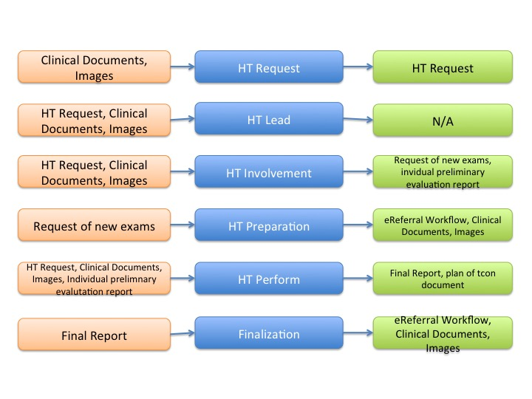

Figure X.4.1.4-1: Workflow Tasks for the Heart Team process

The XCHT-WD process flow, including the task states/status is shown in Figure X.4.1.4-2.

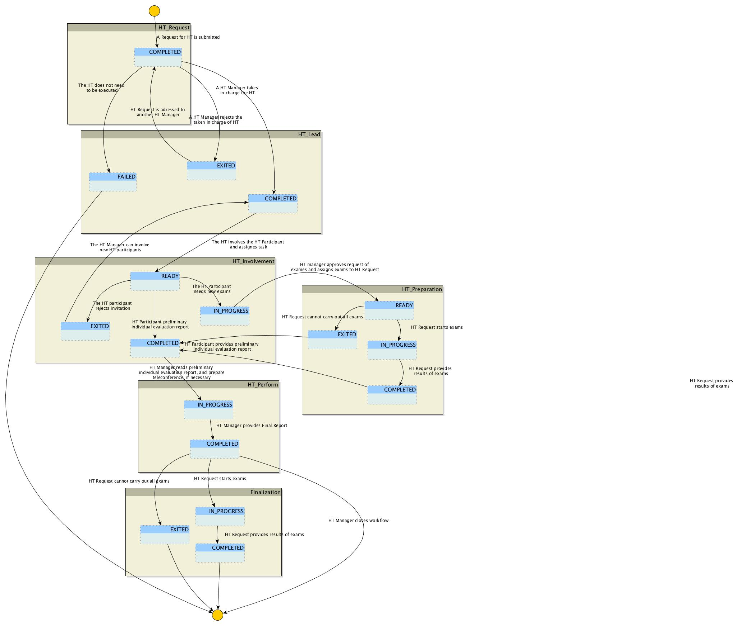

Figure X.4.1.4-2: Cross-Enterprise Cardiovascular Heart Team Workflow Definition complete process flow

The following table X.4.1.4-1 lists the various documents that shall, conditional, or may be referenced as either input or output documents for each task/status pair defined by the XCHT-WD.

The values used in the Option column are defined as follows:

**R:** Required. Compliant source systems shall provide the document as referenced.

**RE**: Required if present.

**C:** Conditional. Compliant source systems shall provide the document referenced if the document is available.

**O:** Optional. Compliant source systems may choose to provide the document reference.

**N/A:** Not Applicable.

|  |  |  |  |  |  |  |
| --- | --- | --- | --- | --- | --- | --- |
| **Task** | **Workflow Participant** | **Task Status** | **Input docs** | **Option** | **Output docs** | **Option** |
| HT_Request (1..1) | HT Requestor | COMPLETED | Clinical Documents and images | R | HT Request | R |
| HT_Lead (1..n) | HT Manager | COMPLETED | Clinical Documents and images,  HT Request | R | N/A | - |
| EXITED |  | - | N/A | - |
| FAILED |  | - | Exception Report | R |
| HT_Involvement (1..n) | HT Participant | READY | Clinical Documents and images,  HT Request | R | N/A |  |
| IN_PROGRESS |  |  | Referral Request | R |
| COMPLETED | eReferral Workflow Document | R | Individual preliminary evaluation report | R |
| EXITED |  |  | N/A | - |
| HT_Preparation (0..1) | HT Requestor | READY | Referral Requests | R | N/A | - |
| IN_PROGRESS | Referral Requests | R | N/A | - |
| COMPLETED |  |  | eReferral Workflow Documents or Clinical documents, Motivation | R |
| EXITED |  |  | Motivation | R |
| HT_Perform (1…1) | HT Manager | IN_PROGRESS | Clinical Documents and Images,  HT Request,  eReferral Workflow Documents,  Individual preliminary evaluation report | R | N/A | O |
| COMPLETED |  |  | Final Report | R |
| Finalization (1…1) | HT Requestor | IN_PROGRESS | Final Report | R | N/A | - |
| COMPLETED |  |  | eReferral Workflow Document or Clinical documents | R |
| EXITED |  |  | N/A | - |

Table X.4.1.4-1: Tasks/Documents related to the Cross-Enterprise Cardiovascular Heart Team process

The Workflow Actors involved in the XCHT-WD process are shown with the workflow task/status transactions in Figure X.4.1.4-3.

A Workflow Participant Actor is an abstraction of system along with users involved in the XCHT process. They can be identified, based on their roles in the process, as one of four specific IHE Actors. Each of these workflow participants has specific rights and duties in the process. They drive the process from one step to another, performing determinate actions on the workflow.

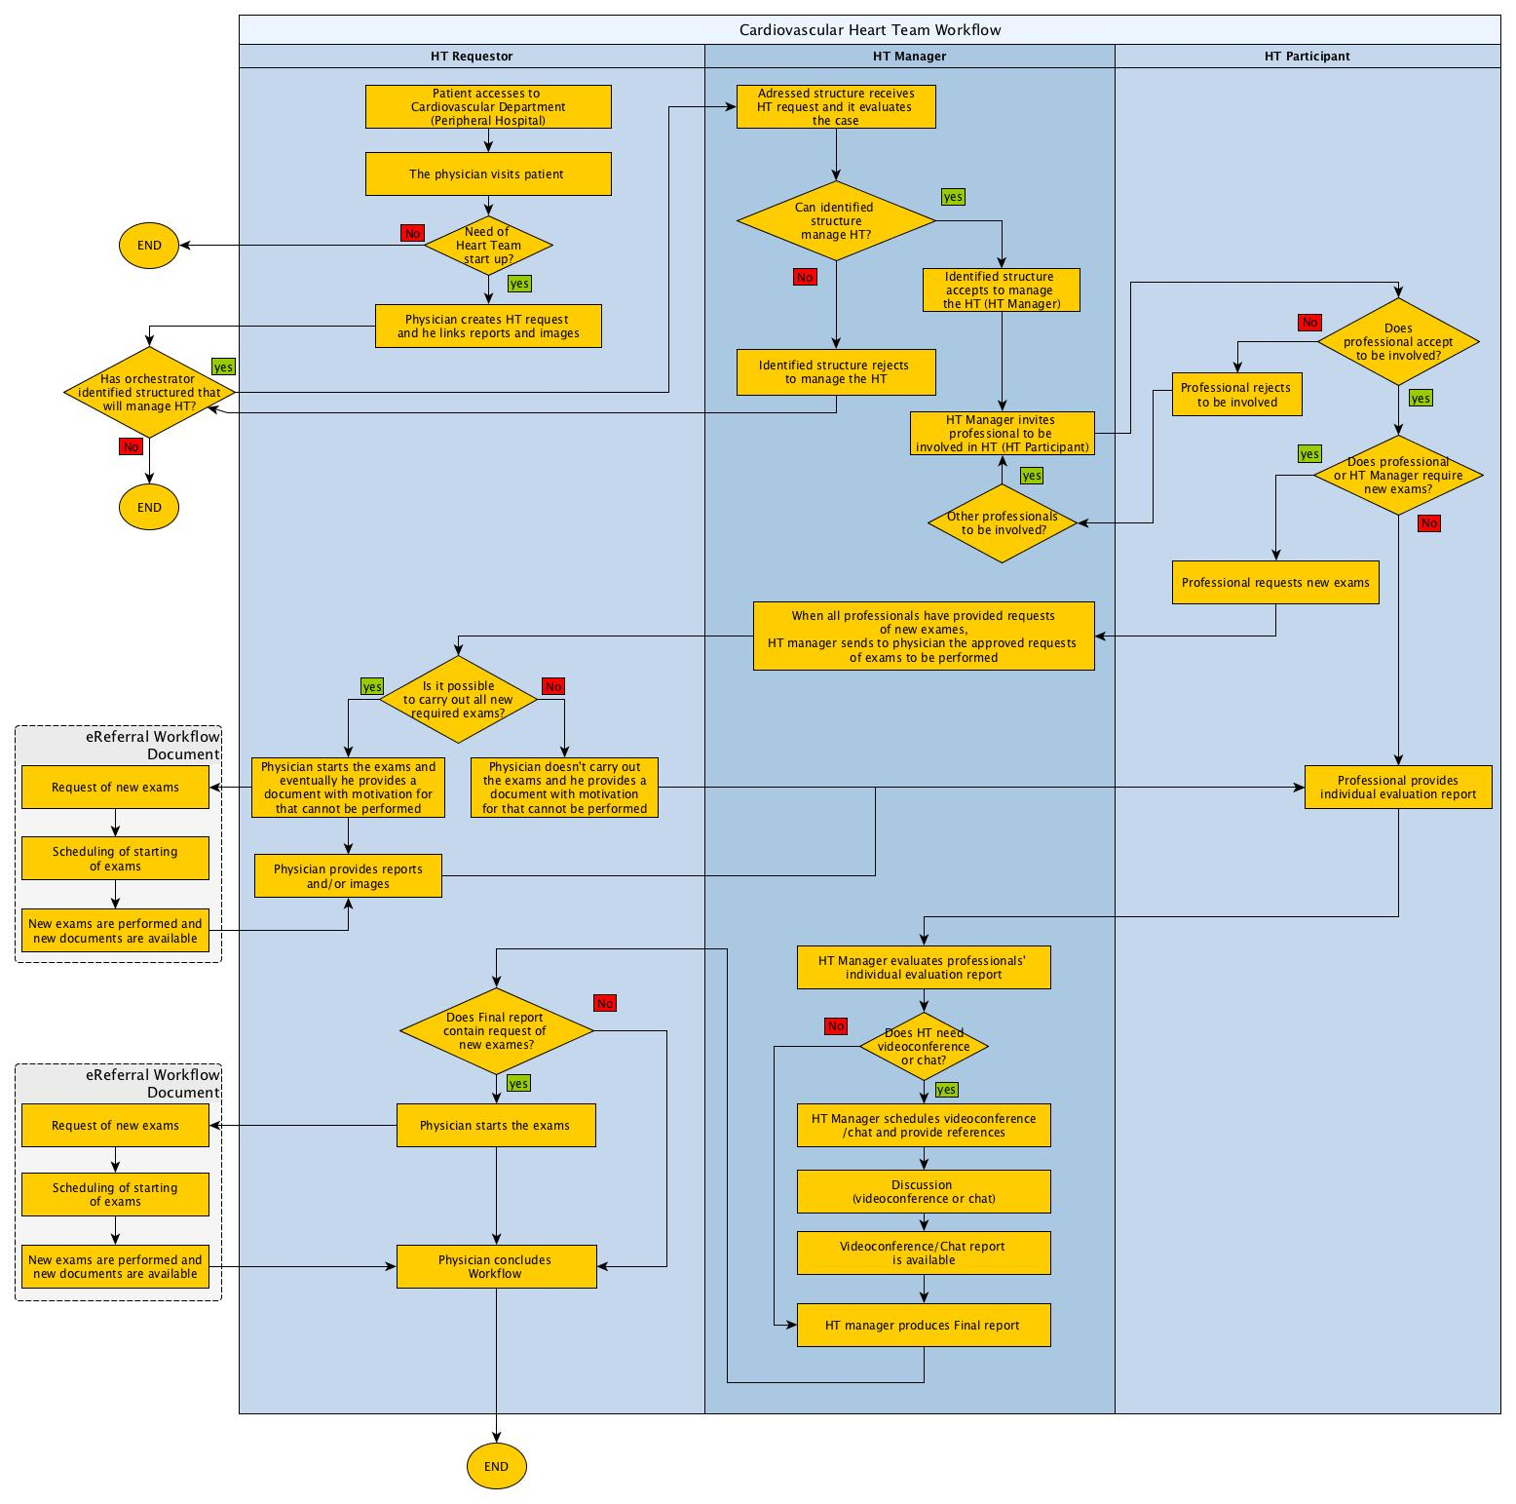

Figure X.4.1.4-3: XCHT-WD Actor Workflow Transitions Diagram

### X.4.2 Use Cases

The use cases are based on the following context of a generic territory composed of many type of structures and professionals:

* Peripheral Hospitals without cathlab and without cardiac surgery (HA), where Dr. Smith, a cardiologist, works;
* Peripheral Hospitals with cathlab but without cardiac surgery (HB), where Dr. Brown, Cardiologist, and Dr. Ralph, interventional cardiologist, work;
* Highly Specialized Hospitals (HC), where Dr. Johnson, a cardiac surgeon, works. HCs can support Peripheral Hospitals
* Highly Specialized Hospitals (HD), where Dr. Home, a cardiac surgeon, works. HDs can support Peripheral Hospitals and they are authorized to provide highly specialized interventions, such us heart transplant or implants of all types of mechanical cardiac support.

Two use cases are described in this profile. The first use case covers a simple management of interaction between an interventional cardiologist belong to peripheral hospital and a cardiac surgeon belong to highly specialized central (basic Hearth Team) in order to share and choice the best treatment strategy for the patient. The second use case covers a complex management of interaction among professionals involved in an extensive Heart Team.

In these use cases a specific disease is considered, but they can be applied to many other diseases.

#### X.4.2.1 Use Case #1: Basic Heart Team Process

The following Use Case illustrates the workflow of management of Cross-enterprise Cardiovascular Heart Team in a cross-enerprise setting, where a Peripheral Hospital (with a cardiac department including cathlab authorized to perform PCI) need support from the Heart Team in order to decide how to treat the patient. In this use case, the HT is composed of Peripheral Hospital (HA) with interventional cardiologist and an Highly specialized Hospital (HC) with a cardiac surgery department. The Use Case illustrates a specific disease, but it can be applied to many other cardiovascular diseases.

##### X.4.2.1.1 Basic Heart Team Process Use Case Description

1. **Request of start-up of Heart Team**

Wednesday morning, Dr. Brown, an interventional cardiologist in peripheral hospital B (HB), visits a 67-year-old male patient with hypertension and without a previous history of cardiac disease started complaining of effort angina, CCS class III. The patient undergone to a cardiac echocardiogram to evaluate the heart functionality. The systolic function of the left ventricle was normal, with an ejection fraction of 60%. Dr. Brown decides to evaluate the patient with a coronary angiography on friday. The coronarography reveals critical (90%) stenosis at the ostium of the left anterior descending (LAD) and left circumflex (LCX) coronary arteries, and diffuse disease of the right coronary artery (RCA). SYNTAX score is 20. Patients with a multi-vessels stenosis and with SYNTAX score ≤22 shall be discussed in a HT, as this is a Class I recommendation in management of patients with complex coronary disease in guidelines issued by American and European professional organizations.

Dr. Brown decides to involve HT in order to take decision on the treatment of patient. Dr. Brown selects the data to share with HT, and Dr. Brown’s secretary prepares HT Request Document in order to activate the HT. Through an IT infrastructure (supported by XDS, DSUB, XDW profiles) and on the base of local policies, the HT Request is addressed to a specific Highly Specialized Hospital with Cardiac Surgery (HC). The HT Request Document links the following documents and images: Medical history, Drug therapy, Biochemical profile test blood, Euroscore II and Syntax score, ECG (Image), echocardiogram, Angiography and ventriculography (Cine-loops). In addition, the cardiologist’s software creates automatically the new workflow document for this case, and this document is shared through the same IT infrastructure. This document will be updated by each next activity.

**B. Definition of Manager of HT**

Cardiac surgery‘s software in HC is notified for the HT Request, through an IT infrastructure. The first cardiac surgeon available is Dr. Johnson. He retrieves documents and images, and he studies the clinical case. Dr Johnson decides that he is able to manage the HT on this case. For this reason, the Dr. Johnson’s secretary specifies in the Dr. Johnson’s Software that he takes charge the management of this HT for this clinical case. Through IT infrastructure, Dr. Brown is notified on the taking charge of HT.

**C. Involvement of participants to HT**

Dr Johnson has to decide who involve in the HT. He decides that don’t need to involve other professionals, in addition to himself and Dr. Brown. The composition of HT is completed.

In order to collect all information useful to decide the appropriate treatement for patient, Dr. Johnson decides that a new most recent echocardiogram (Cine-loops) is preferable to evaluate the treatment strategy. Therefore, through IT infrastructure, Dr. Johnson produces the request to carry out echocardiogram, and the person that take charge the patient, Dr. Brown, is notified to do it.

**D. Preparation of HT**

1. Dr. Brown starts the procedures.
2. When the new echocardiogram is available, this is notified to HT members through an IT infrastructure, and all participants of the HT can see the clinical documents and images.

**E. Providing of a preliminary individual evaluation report**

On base of all clinical documents and images, Dr. Johnson provides a preliminary individual report.

**F. Taken Decision by HT**

1. Dr. Johnson decides it is better to speak with Dr. Brown through a videoconference. Secretary of Dr. Johnson defines in the system that a virtually meeting will start next Monday at 10.00, and Dr. Brown is notified on it through an IT infrastructure.
2. The professionals involved to HT meet each other in a videoconference Monday at 10.00. The HT analyzes the clinical case and the actually clinical patient status to achieve the optimal choice for the patient’s treatment. The taken decision is a CABG intervention, and therefore they concluded that patient have to be treated in HC. Dr. Johnson creates final report on base of the decision taken during the videoconference. The final report contains also the list of exams required by Dr. Johnson for the preparation of the intervention: Hemogasanalysis and Eco-color doppler (Cine-loops). The document is the formal answer of the HT. Through the IT infrastructure, the document is now available for all HT members and all participants are notified.

**G. Finalization of needed documents for intervention or treatment**

1. On base of final report, Dr. Brown starts the exam.
2. When results are available, Dr. Johnson is notified and he retrieves results. The secretary of hospital C calls the patient and schedules the intervention.

##### X.4.2.1.2 Basic Heart Team Process Flow

The following sequence of tasks within the workflow describes the typical process flow for the Common Workflow scenario.

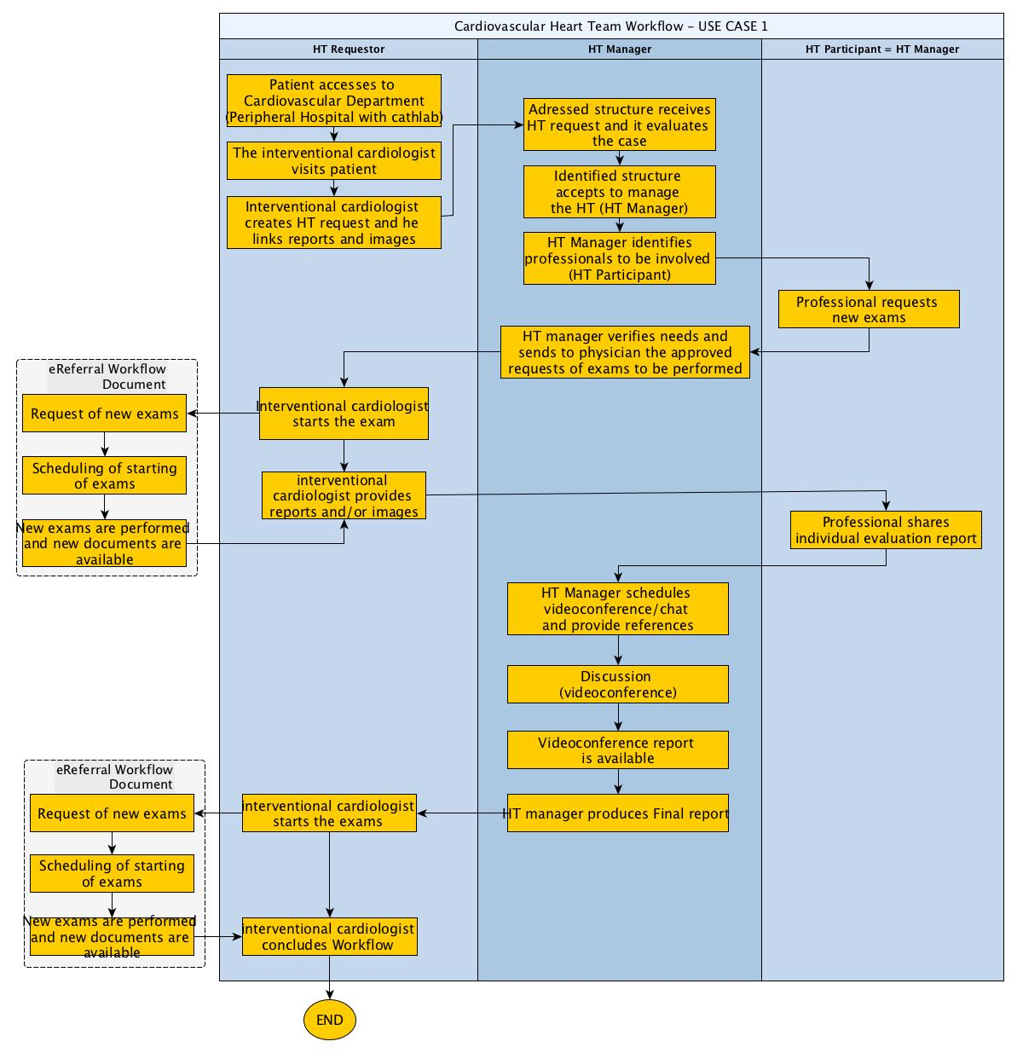

Figure X.4.2.1.2-1: XCHT-WD Basic process flow

#### X.4.2.2 Use Case #2: Complex Heart Team Scenario

The following Use Case illustrates the workflow of management of Cross-enterprise Cardiovascular Heart Team in a cross-enerprise setting, where a Peripheral Hospital (with a cardiac department that not included cathlab) need support from the Heart Team in order to decide how to treat the patient. In this use case, the HT is composed of Peripheral Hospital, an two Highly Specialized Hospital (HC and HD) with cardiac surgery department. The Use Case illustrates a specific disease, but it can be applied to many other cardiovascular diseases.

**X.4.2.2.1 Complex Heart Team Scenario use-case description**

**A. Request og Start-up of Heart Team**

Wednesday morning, Dr. Smith, an interventional cardiologist in peripheral hospital B (HB), visits a 67-year-old male patient with hypertension and without a previous history of cardiac disease started complaining of effort angina, CCS class III. The patient undergone to a cardiac echocardiogram to evaluate the heart functionality. The systolic function of the left ventricle was normal, with an ejection fraction of 60%. Dr. Smith decides to evaluate the patient with a coronary angiography on Friday, and he referrals patient to Dr. Brown. The coronarography reveals critical (90%) stenosis at the ostium of the left anterior descending (LAD) and left circumflex (LCX) coronary arteries, and diffuse disease of the right coronary artery (RCA). SYNTAX score is 20. Patients with a multi-vessels stenosis and with SYNTAX score ≤22 shall be discussed in a HT, as this is a Class I recommendation in management of patients with complex coronary disease in guidelines issued by American and European professional organizations.

Dr. Smith decides to involve HT in order to take decision on the treatment of patient. Dr. Smith selects the data to share with HT, and Dr. Smith’s secretary prepares HT Request Document in order to activate the HT. Through an IT infrastructure (supported by XDS, DSUB, XDW profiles) and on the base of local policies, the HT Request is addressed to a specific Highly Specialized Hospital with Cardiac Surgery (HC1). The HT Request Document links the following documents and images: Medical history, Drug therapy, Biochemical profile test blood, Euroscore II and Syntax score, ECG (Image), echocardiogram, Angiography and ventriculography (Cine-loops). In addition, the cardiologist’s software creates automatically the new workflow document for this case, and this document is shared through the same IT infrastructure. This document will be updated by each next activity.

**B. Definition of Manager of HT**

Cardiac surgery‘s software in HC1 is notified for the HT Request, through an IT infrastructure. The first cardiac surgeon available is Dr. Johnson. He retrieves documents and images, and he studies the clinical case. Dr Johnson decides that he is not able to manage the HT on this case, because the case is very complex, and decides that HC2 can better manage this case.

The HT Request is addresses to HC2. The first cardiac surgeon available is Dr. John. For this reason, the Dr. John ’s secretary specifies in the Dr. John’s Software that he takes charge the management of this HT for this clinical case. Through IT infrastructure, Dr. Smith is notified on the taking charge of HT.

**C. Involvement of participants to HT**

Dr John has to decide who involve in the HT. He decides that needs to involve Dr. Bown because is the interventional cardiologist that carried out previous coronarography, and Dr. Ralph, an cardiothoracic anesthesiologist that works with Dr. John, in addition to himself and Dr. Smith. The composition of HT is completed. All potential participants are notified.

Software of Dr. Ralph rejects the invitation because he don’t confirm his participation to HT in time. Dr. John decides he can take a decision without Dr. Ralph.

In order to collect all information useful to decide the appropriate treatement for patient, Dr. Brown decides that a new most recent echocardiogram (Cine-loops) is preferable to evaluate the treatment strategy. Therefore, through IT infrastructure, Dr. Brown produces the request to carry out echocardiogram. Dr. John approves this request, and the person that take charge the patient, Dr. Smith, is notified to do it.

**D. Preparation of HT**

1. Dr. Smith starts the procedures.
2. When the new echocardiogram is available, this is notified to HT members through an IT infrastructure, and all participants of the HT can see the clinical documents and images.

**E. Providing of a preliminary individual evaluation report**

On base of all clinical documents and images, Dr. John and Dr. Brown provide a preliminary individual reports, that are shared with HT.

**F. Taken Decision by HT**

Dr. John analyses preliminary individual reports by Dr. Brown. The conclusion of Dr. Brown is equal to its: the taken decision is a PCI intervention, and therefore the patient have to be treated in HB. For this reason, Dr. Jhon decides that it isn’t necessary to start a videoconference.

Dr. John creates final report, that the taken decision. Adding exams are not necessary. The document is the formal answer of the HT for Dr. Smith and Dr. Brown. Through the IT infrastructure, the document is now available for all HT members and all participants are notified.

#### X.4.2.3 Use Case #3: Failing situations Requesting HT Scenario

**Failing of the requesting process**

In the first case the HT Requester wants to abort the process just created, for example because HT Request is wrong or uncompleted or the patient is died.

## X.5 XCHT-WD Security Considerations

For this section please refer to the section ITI TF-1: 30.5

## X.6 XCHT-WD Cross Profile Considerations

In this section are defined some relationship of this profile with other profiles. These dependencies shall not be considered additional requirements for Actors involved in the Cross-Enterprise Cardiovascular Heart Team workflow.

Document Metadata Subscription profile (DSUB) does provide a notification platform that support the pull-style approach in accessing notification content. However in many cases, a push-style approach is preferred. In such a cases, for temporary system faults, some notifications received on a transport layer could not be processed correctly at the application layer. To avoid loss of information, the Remote Read Dispatcher actor should be able to Pull workflow documents of interest. This can be done via MPQ Registry Stored Query.

Appendices

<Add Appendices to this Profile here. Examples of an appendix include HITSP mapping to IHE Use Cases or long use case definitions.>

<Volume 1 Appendices are informational only. No “SHALL” language is allowed in a Volume 1 appendix.>

* + 1. Appendix A - Actor Summary Definitions

Add the following terms to the IHE Technical Frameworks General Introduction Namespace list of Actors:

<Add any actor definitions for new actors defined specifically for this profile. These will be added to the IHE TF General Introduction list of Actors namespace. This section will be deleted prior to inclusion into the Technical Framework Final Text.>

* + 1. Appendix B - Transaction Summary Definitions

Add the following terms to the IHE Technical Frameworks General Introduction Namespace list of Transactions:

<Add any transaction definitions for new transactions defined specifically for this profile. These will be added to the IHE TF General Introduction list of Transactions namespace. This section will be deleted prior to inclusion into the Technical Framework Final Text. >

Glossary

Add the following terms to the IHE Technical Frameworks General Introduction Glossary:

<Any glossary additions associated with the profile draft go here. This section will be deleted prior to inclusion into the Technical Framework Final Text. >

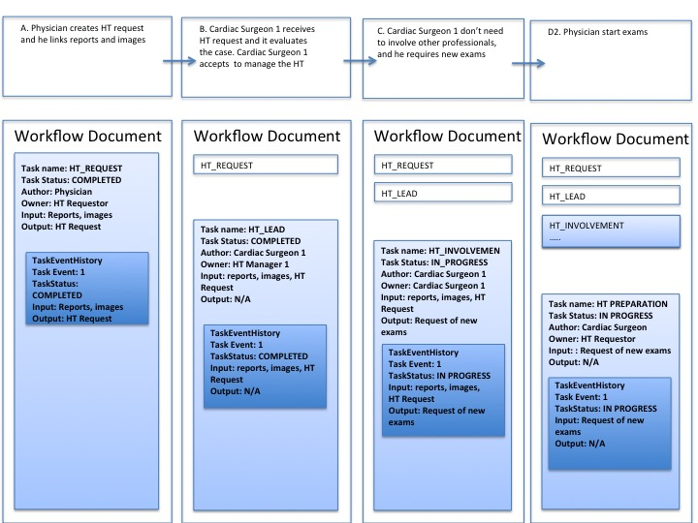

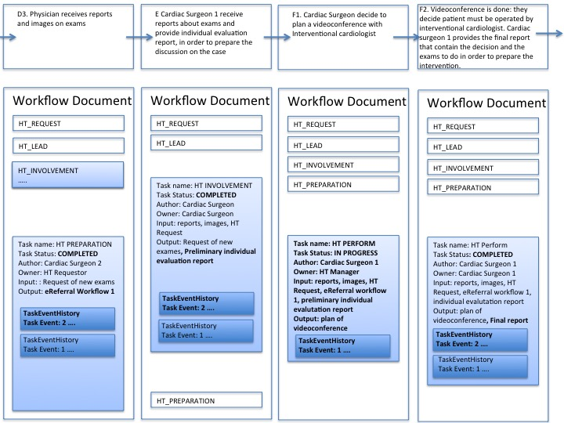

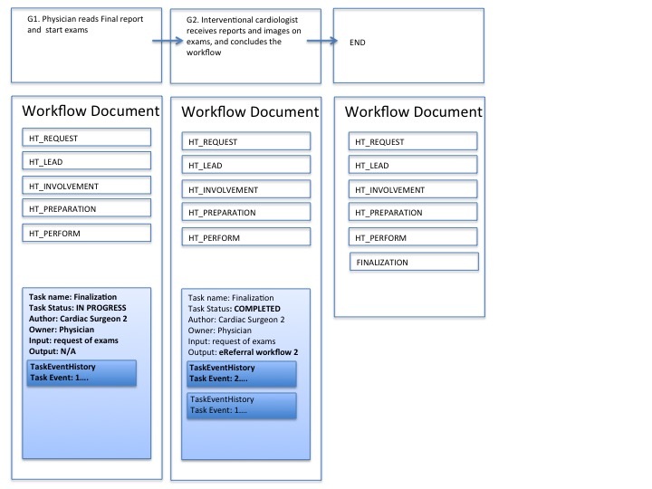

Figure X.3.1.1-1: Management of the Workflow Document in a basic process flow (USE CASE 1)

Volume 2 – Transactions

Add section 3.Y

## 3.Y Submit Read Request RAD-XX

### 3.Y.1 Scope

### 3.Y.2 Actor Roles

<Optional: if desired, add a diagram as shown below to illustrate the actors included in this transaction, or delete the diagram altogether.>

Actor ABC

Actor DEF

|  |  |
| --- | --- |
| **Actor:** | Remote Read Requester |
| **Role:** | It creates a Read Request and submits it. |
| **Actor:** | Remote Read Dispatcher |
| **Role:** | It is notified for pending Read Requests and takes them in charge |
| **Actor:** | Remote Read Performer |
| **Role:** | It queries for pending Read Requests |

### 3.Y.3 Referenced Standards

<e.g., HL7 2.3.1 Chapters 2, 3>

<e.g., DICOM 2008 PS 3.3: A.35.8 X-Ray Radiation Dose SR IOD>

XDS.b

DSUB

### 3.Y.4 Interaction Diagram

<The interaction diagram shows the detailed standards-based message exchange that makes up the IHE transaction. Add any text here needed to describe this diagram.>



#### 3.Y.4.1 RequestRemoteReadCOMPLETED

This message allows starting the Remote Read workflow sharing Read Request and the Image Manifest that references the Images that are subject of the Read.

This transaction relies on the document transport mechanisms defined by the [ITI-41] Provide And Register Document Set-b transaction and by the [ITI-53] Document metadata Notify transaction. Section X.X.X defines document sharing metadata binding for documents involved in the XRR-WD workflow.

##### 3.Y.4.1.1 Trigger Events

##### This message is sent when the Remote read Requester wants to start a Remote Read process and has acquired and collected all the information needed.

* A Read Request Document: the request for a Radiologist to perform a clinical read of images acquired for a Requested Procedure.
* An Images Manifest: a document identifying the image set subject of the Read Request.
* The workflowInstanceId of the previous Read process: if the Read process is classified as a “Read Over the Read” by the Remote Read Requester.

##### 3.Y.4.1.2 Message Semantics

This message is a Provide And Register Document Set-b Request message sent by the Remote Read Requester actor.

This message shall comply with the message semantics defined for the Provide And Register Document Set-b Request message ITI TF-2b:3.41.4.1.2.

The following sections specify further Document Sharing Metadata requirements, the actual Workflow Document Content and the Read Request content.

##### 3.Y.4.1.2.1 Document Sharing Metadata requirements

It is not required that all the documents referenced within the Workflow Document are included in the same submissionSet.

The document sharing metadata and submissionSet metadata shall comply with requirements in section X.X.X.

The document sharing metadata of the Workflow Document shall meet the following constraints:

* One occurrence of eventCodeList metadata shall convey the actual status (OPEN) of the workflow: code = “urn:ihe:iti:xdw:2011:eventCode:open” codingScheme=” 1.3.6.1.4.1.19376.1.2.3”
* One occurrence of the eventCodeList metadata shall convey the actual status of the Request Remote Read task: code=”urn:ihe:rad:xrr-wd:2015:eventCodeTaskStatus:RequestReadCompleted” codingScheme=”1.3.6.1.4.1.19376.1.2.1”

The submissionSet metadata of the Workflow Document shall meet the following constraints:

* The intendedRecipient metadata may contain the identifier of the organization, group of people or organizations, or the person intended to execute the Read.

The document sharing metadata of the Read Request document shall meet the following constraints:

* One occurrence of eventCodeList metadata shall convey the type of the Read just requested (codingScheme=”1.3.6.1.4.1.19376.1.2.1”):
  + If the Read requested does not have specific workflow requirements, code: “urn:ihe:rad:xrr-wd:2015:normalRead”
  + If the Remote Read Requester is asking for a Double Read, code: “urn:ihe:rad:xrr-wd:2015:doubleRead”
  + If the Remote Read Requester is asking for a Read over the Read, code: “urn:ihe:rad:xrr-wd:2015:readOverRead”

##### 3.Y.4.1.2.2 XDW Content Requirements

##### 3.Y.4.1.2.2.1 Workflow Document Header

The Remote Read Requester shall set the value for the **<WorkflowStatus>** to “OPEN”.

The Remote Read Requester shall set the value of the **<workflowDefinitionReference>** to “1.2.3.4.5.6.7.8.9.0”.

This transaction does not define further specific requirements for the Header of this message. See ITI TF-3: 5.4 for further details.

##### 3.Y.4.1.2.2.2 Workflow Document taskList

This message is structured in accordance to the XDW (Cross-Enterprise Document Workflow) profile, with the following additional constraints:

The **<taskList>** elment shall have only one child element **<XDWTask>**.

##### 3.Y.4.1.2.2.3 Task “Request Remote Read”

The **<XDWTask>** element shall have a **taskData/taskDetails/taskType** child element with value “Request Remote Read” and a **taskData/taskDetails/status** child elementwith value “COMPLETED”.

The Remote Read Requester shall set the value of the element **taskData/taskDetails/priority** based on the urgency of the Read Request referenced. The value shall be set in accordance to the following conventions:

* 0: HIGH PRIORITY
* 5: NORMAL PRIORITY
* 10: LOW PRIORITY

The Remote Read Requester actor could set the value of additional elements that characterize the nature and the execution of the Read Requested:

* **taskData/taskDetails/expirationTime**: this elements allows the Remote Read Requester to specify a date/time by which the Read need to be completed
* **taskData/taskDetails/notificationRecipients:** this elements allows to identify user/organization that needs to be notified. If this element has one o more values, the same user/organization shall be identified as SubmissionSet.intededRecipient for the submission that will result in the publication of the Workflow Document itself.

The element **<XDWTask>** shall have a child element taskData/input/part for each document referenced as input of the task itself. Document that shall/can be referenced as input are listed below (further details about attachmentEncoding are specified at ITI TF-3:5.4.3):

* **part/@name**=”ImageManifest”: (1..1) this is a required input that identifies the Image Manifest of the images that can be. This reference shall be present
* **part/@name** =”ReadRequest”: (1..1) this is a required input that identifies the Read Request.
* **part/@name** =”ClinicalDocuments”: (0..N) this is an optional and repeatable input that identifies relevant Clinical Document.
* **part/@name** =”relevantImageManifest”: (0..N) this is an optional and repeatable input that identifies relevant Image Manifest not object of the Read.
* **part/@name** =”XXXX” (O..1) conditional

The element **<XDWTask>** shall have only one child element **taskEventHistory/taskEvent**. characterized by **startOwner** = **actualOwner** = Remote Read Requester and **status** = “COMLETED”.

##### 3.Y.4.1.2.3 Read Request Content Requirements

This specification requires that the Read Request document conveys at least the actual OMI order message base64 encoded.

The Remote Read Requester shall grant that this OMI message provides the codes that are interpretable to all the actors belonging to the Affinity Domain.

##### 3.Y.4.1.3 Expected Actions

The XDS Document Repository shall process the Provide and Register Document Set-b Request message as described in section ITI TF-2b:3.41.4.1.3.

#### 3.Y.4.2 Provide And Register Document set-b Response

See section ITI TF-2b:3.41.4.2

##### 3.Y.4.2.1 Trigger Events

See section ITI TF-2b:3.41.4.2.1

##### 3.Y.4.2.2 Message Semantics

See section ITI TF-2b:3.41.4.2.2

##### 3.Y.4.2.3 Expected Actions

See section ITI TF-2b:3.41.4.2.3.

In addition to the default Expected Actions defined for the Provide And Register Document Set-b Response message, when this message delivers a Response of Success (See ITI TF-3: 4.2.4.2)to the Remote read Requester actor, the Remote Reader Requester shall save the workflowInstanceId associated to the workflow. That id should be used for subsequents subscriptions.

In addition to that, when the Remote Read Requester receives a Provide And Register Document Set-b Response message conveying a result of Success, then the Remote Read Requester shall initiate a [ITI-52] Document Metadata Subscribe, subscribing for notifications triggered by any update that will occurs the specific workflow just initiated. The Read Requester shall create a subscription that identifies the specific Workflow Instance Id as a filter parameter for the creation of notifications. This subscription is characterized by the following parameters:

* *TerminationTime =* unspecified. This allows to create a subscription without an expiration date/time;
* *topics* = “ihe:FullDocumentEntry”. This allows receiving notifications that convey the full documentEntry metadata related to the Workflow Document published.
* *Subscription Filter* = “urn:uuid:aa2332d0-f8fe-11e0-be50-0800200c9a66” (Subscriptions for DocumentEntry metadata). This allows to subscribe for documents published with specific metadata.
* *$XDSDocumentEntryReferenceIdList filter* = workflow Instance Id.

From this time, any update to the workflow document is notified to the Remote Read Requester.

#### 3.Y.4.2 Notify

See section ITI TF-2b:3.53.4.2

##### 3.Y.4.2.1 Trigger Events

The DSUB Document Metadata Notification Broker creates this message when an updated Workflow Document is correctly published.

##### 3.Y.4.2.2 Message Semantics

See section ITI TF-2b:3.53.4.2.2

##### 3.Y.4.2.3 Expected Actions

See section ITI TF-2b:3.53.4.2.3.

In addition to the default Expected Actions defined for the Notify message within the transaction [ITI-53] Document Metadata Notify, if this message is received by the Remote Read Dispatcher actor, the Remote Reader Dispatcher actor shall be able to initiate the transaction [RAD-YY] Assign Read Request. If the Notify message is received by the Remote Read Performer, than the Remote Read Dispatcher shall be able to initiate a Query for Remote Read transaction [RAD-QQ]. ,

### 3.Y.5 Security Considerations

#### See section ITI TF-2b:3.41.5 and ITI TF-2b:3.53.5

#### 3.Y.5.1 Security Audit Considerations

#### See section ITI TF-2b:3.41.5.1 and ITI TF-2b:3.53.5.1

<Appendix letter> Appendix Name

<Detailed cross transaction relationships or mapping details are described in an appendix in Volume 2x. Volume 2 appendices may be informational or normative. Immediately after the title of a Volume 2 appendix, provide a very explicit statement defining whether this new appendix is informative or normative.>

Volume 2 Namespace Additions

(Should this should be in Volume 1 and/or Volume 3 also/instead? Content Module OIDs are defined in Volume 3; possibly under the Glossary section in Volume 1.>

Add the following terms to the IHE Namespace:

<Please explicitly identify all new OIDs, UIDs, URNs, etc., defined specifically for this profile. These will be added to the IHE TF General Introduction namespace appendix when it becomes available. These items should be collected from the sections above, and listed here as additions when this document is published for Trial Implementation. This section will be deleted prior to inclusion into the Technical Framework as Final Text, but should be present for publication of Public Comment and Trial Implementation.>

Volume 3 – Content Modules

<The current version of the supplement template only addresses HL7 v3 CDA Content Modules. All CDA Content Modules will go in Section 6 of Volume 3 of each domain’s Technical Framework document. In the future, this supplement template may have additional sections for DICOM Content Modules (section 7 of Volume 3) and other types of Content Modules (section 8, etc., of Volume 3).>

3.Y.4.1.2.2 Workfow Document sharing metadata

Table 1.3-1: Workflow Document Metadata binding

| Document Sharing Metadata | Definition |
| --- | --- |
| typeCode | For the Workflow Document which tracks the XRR-WD process the code for the typeCode shall be:  XRR-WD  and the codingScheme shall be:  1.3.6.1.4.1.19376.1.1 |
| eventCodeList | For an Remote Read Workflow Document, one code of this list shall be used to define the active task and status of the workflow when the document is updated. This code shall have one of the following values:   * code value =   urn:ihe:xrr-wd:2015:eventCodeTask:RequestReadCompleted   * code value =   urn:ihe:xrr-wd:2015:eventCodeTask:RequestReadFailed   * code value =   urn:ihe:xrr-wd:2015:eventCodeTask:RequestReadInProgress   * code value =   urn:ihe:xrr-wd:2015:eventCodeTask:DispatchReadCompleted   * code value =   urn:ihe:xrr-wd:2015:eventCodeTask:DispatchReadInProgress   * code value =   urn:ihe:xrr-wd:2015:eventCodeTask:DispatchReadFailed   * code value =   urn:ihe:xrr-wd::2015:eventCodeTask:PerformReadReady   * code value =   urn:ihe:rad:xrr-wd::2015:eventCodeTask:PerformReadInProgress   * code value =   urn:ihe:rad:xrr-wd::2015:eventCodeTask:PerformReadCompleted   * code value =   urn:ihe:rad:xrr-wd::2015:eventCodeTask:PerformReadFailed   * code value =   urn:ihe:rad:xrr-wd::2015:eventCodeTask:PerformReadExited   * code value =   urn:ihe:rad:xrr-wd::2015:eventCodeTask:CompleteReadComplete  codingScheme = 1.3.6.1.4.1.19376.1.1  The value shall be updated when the Workflow Document is updated with the active task status. For further details see section XXXX |
| serviceStartTime | It is the time at which the Request Remote Read task is created in status COMPLETED or IN_PROGRESS. |
| serviceStopTime | It is the time at which the status of the overall Workflow is changed from OPEN to CLOSED.  It shall be empty when the workflow is still in OPEN state. |

## 3.Y.4.1.2.2 Image Manifest Metadata

Image Manifest DocumentEntry Metadata Requirements are provided in the transaction [RAD-68]: RAD TF-3: 4.68.

**3.Y.4.1.2.3 Read Request Metadata**

Specific requirements for Read Request document metadata are listed in the Table below which are specified by XDS-I. The constraints include the mapping requirements from the content to the metadata attribute. Note that the Optionality specified in this table supersedes the Optionality specified in ITI TF-3: Table 4.3.2.1-3 “Metadata Attribute Optionality” for the XDS Document Registry Actor where there are differences.

| Document Sharing Metadata | Metadata Attribute | Opt. | Remote Read Constraints |
| --- | --- | --- | --- |
| DocumentEntry | author: authorPerson | R | RAD TF-3: 4.68.4.1.2.3.1 |
| DocumentEntry | author: authorInstitution | O | RAD TF-3: 4.68.4.1.2.3.1 |
| DocumentEntry | author: authorRole | O | RAD TF -3: 4.68.4.1.2.3.1 |
| DocumentEntry | author: authorSpecialty | O | RAD TF -3: 4.68.4.1.2.3.1 |
| DocumentEntry | eventCodeList | R | This metadata shall be valorized as describe in RAD TF -3: 4.68.4.1.2.3.2.  In addition to that, the XRR-WD define an additional requirement. The eventCodeList metadata shall be used to classify the type of Read process needed:  code: “DOUBLE_READ”  code: “READ_OVER_READ”  code: “NORMAL”  codingScheme= 1.3.6.1.4.1.19376.1.1 |
| DocumentEntry | practiceSettingCode | R | RAD TF-3: 4.68.4.1.2.3.2 |
| DocumentEntry | serviceStartTime | R2 | RAD TF-3: 4.68.4.1.2.3.2 |
| DocumentEntry | sourcePatientInfo | O | RAD TF-3: 4.68.4.1.2.3.2 |
| DocumentEntry | typeCode | R | RAD TF-3: 4.68.4.1.2.3.2 |
| DocumentEntry | typeCodeDisplayName | R | RAD TF-3: 4.68.4.1.2.3.2 |
| DocumentEntry | referenceIdList | R2 | RAD TF-3:4.68.4.1.2.3.2  RAD TF-3:4.68.4.1.2.3.3 |

# 5. Namespaces and Vocabularies

Add to section 5 Namespaces and Vocabularies

<Note that the code systems already defined in the Technical Framework of this domain may (but not required) be replicated here just to aid in the supplement review as a standalone document. Also note that the Section 5 table numbers and names are already defined in the TF Vol 3.>

| codeSystem | codeSystemName | Description |
| --- | --- | --- |
| <oid or uid> | <code system name> | <short description or pointer to more detailed description> |
| <oid or uid> | <code system name> | <short description or pointer to more detailed description> |
| <oid or uid> | <code system name> | <short description or pointer to more detailed description> |

Add to section 5.1.1 IHE Format Codes

| Profile | Format Code | Media Type | Template ID |
| --- | --- | --- | --- |
| <Profile name (profile acronym)> | <urn:ihe: > |  | <oids> |
|  |  |  |  |
|  |  |  |  |

Add to section 5.1.2 IHE ActCode Vocabulary

|  |  |
| --- | --- |
| Code | Description |
| <Code name> | <short one sentence description or reference to longer description (not preferred)> |
| <Code name> | <short one sentence description or reference to longer description (not preferred)> |
| <Code name> | <short one sentence description or reference to longer description (not preferred)> |

Add to section 5.1.3 IHE RoleCode Vocabulary

| Code | Description |
| --- | --- |
| <name of role> | <Short, one sentence description of role or reference to more info.> |
| <name of role> | <Short, one sentence description of role or reference to more info.> |
| <name of role> | <Short, one sentence description of role or reference to more info.> |

# 6. Content Modules

<Authors’ notes: This section of the supplement template is only for HL7 v3 CDA Content Module definitions. Please delete the entire section 6.3.1 if the Content Module is based on DICOM or another standard.

Please note that the template for DICOM or other types of content modules (other than CDA) has not yet been defined, although DICOM modules will eventually go into Volume 3 Section 7; yet another type of content module will go into Volume 3 Section 8, etc.>

## 6.3.1 CDA Document Content Modules

<Authors’ instructions: The understanding of content module grouping, options, and bindings are critical to CDA content modules. It is strongly recommended that the author review the IHE Technical Frameworks General Introduction section 10.3 and the Patient Care Coordination (PCC) Technical Framework Volume 3 sections 3 and 4 (PCC TF-3:3 and 4) prior to continuing. A critical understanding of CDA definitions for cardinality, optionality, coded terminology values, and CDA content module structure, as well as IHE CDA formatting conventions is also necessary. It is strongly recommended that the author is also conversant with the IHE Technical Frameworks General Introduction Appendix E “Conventions”.>

<This CDA Content Module template is divided into four parts:

D – Document –“D” will be replaced with a sub-section number when added to the Technical Framework

H – Header - “H” will be replaced with a sub-section number when added to the Technical Framework

S – Section - “S” will be replaced with a sub-section number when added to the Technical Framework

E – Entry - “E” will be replaced with a sub-section number when added to the Technical Framework

It is expected that the author will replicate each of these four parts as necessary within a supplement.>

<Examples in Volume 3 are given in blue text. All examples (all blue text) should be deleted after the example has been read and understood.>

Add to section 6.3.1.D Document Content Modules

<Authors’ note: replicate section 6.3.1.D for every CDA Document defined in this profile.>

#### 6.3.1.D <Content Module Name (Acronym)> Document Content Module

##### 6.3.1.D.1 Format Code

The XDSDocumentEntry format code for this content is **urn:ihe:card:imaging:2011**

##### 6.3.1.D.2 Parent Template

<The following text is common, so it is left here for consistency. If it is not relevant, then change the text to the accurate information, but retain the formatting convention. Be sure to include all parent templates.>

This document is a specialization of the IHE PCC Medical Document template (OID = 1.3.6.1.4.1.19376.1.5.3.1.1.1).

Note: The Medical Document includes requirements for various header elements; name, addr and telecom elements for identified persons and organizations; and basic participations record target, author, and legal authenticator.

This document is a specialization of the HL7 Procedure Note template (OID = 2.16.840.1.113883.10.20.18.1).

Note: This document is not a specialization of the HL7 Basic Diagnostic Imaging Report template due to conflicts with two Procedure Note requirements (format of serviceEvent/effectiveTime, and title on DICOM Catalogue section). When and if these are resolved, an instance may also comply to the Diagnostic Imaging Report.

##### 6.3.1.D.3 Referenced Standards

<Identify ALL standards referenced by THIS content module.>

All standards which are reference in this document are listed below with their common abbreviation, full title, and link to the standard.

Table 6.3.1.D.3-1. <Document Name> - Referenced Standards

| Abbrevi-ation | Title | URL |
| --- | --- | --- |
| <abbreviated name of standard> | <full name of standard> | <link to standard> |
| <abbreviated name of standard> | <full name of standard> | <link to standard> |
| e.g., CDA-PN | e.g., HL7 Implementation Guide for CDA Release 2: Procedure Note (Universal Realm) (DSTU) | e.g., http://www.hl7.org/documentcenter/public/standards/dstu/CDAR2_IG_PROCNOTE_DSTU_R1_2010JUL.zip |

##### 6.3.1.D.4 Data Element Requirement Mappings to CDA

<This section can be marked N/A if not needed. Else, any required data mappings should be listed here. The author should add the referenced standards abbreviations in the first row/title bar. Add or delete columns and sub-rows as necessary. If this table is more than 8 to 10 rows long, consider putting this table into an appendix of this supplement.>

*<Delete this example prior to supplement public comment and use the table below instead, retained just as an example to authors:>*

Table 6.3.1.D.4-1 ABCD - Data Element Requirement Mappings to CDA

| ACC Key Data Element (KDECI) | CDA-DIR |
| --- | --- |
|  | **DICOM Object Catalog** (5) |
| Administrative  Facility (5)  Data Source (1)  Priority (1)  Accreditation (2)  Insurance (1) | **CDA Header**  General (10)  Document (19)  Participants (20)  Order (1)  Service Event (12)  Encounter (10) |
| Study Referral Data (2) | Request |
| History and Risk Factors  Vital Signs (4)  Labs (2)  Problems (14)  Chest Pain (5)  Family History (1)  Tobacco Use (1)  Risk Estimates (6) | History |
|  |  |
|  |  |

This section identifies the mapping of data between referenced standards into the CDA implementation guide.

<The right column should contain the xpath to data elements in this document. ???? accurate?>

Table 6.3.1.D.4-1: < Document Name Acronym> - Data Element Requirement Mappings to CDA

| Clinical Data Element <source> | < this document acronym> |
| --- | --- |
|  |  |
|  |  |
|  |  |
|  |  |
|  |  |
|  |  |

<**Very important note:** From this point forward, the author may select one of two formats to represent the same data. The first format is a tabular format as was implemented in the Cardiology CIRC profile. The advantages to this format include that large amounts of data may be represented more concisely and that it is sometimes visually easier to determine if any information is missing. The second format is more similar to the current Consolidated CDA (C-CDA format). This format may be more verbose but may also be more recognizable to implementers familiar with other HL7 CDA Implementation Guides and may be easier for implementers to design and test with discrete conformance assertions.

The format that you select must be consistent through this supplement (do not mix and match formats). The format changes are identified by ###Begin Tabular format ###End CDA Tabular format and ###Begin Discrete Conformance format ###End Discrete Conformance format. Delete all references to the format which was not selected between the hash marks. Also, a domain may decide on a single format for all new supplements within that domain.>

##### 6.3.1.D.5 <Content Module Name (Acronym, if appl)> Document Content Module Specification

This section specifies the header, section, and entry content modules which comprise the <Content Module Name (Acronym)> Document Content Module, using the Template ID as the key identifier.

Sections that are used according to the definitions in other specifications are identified with the relevant specification document. Additional constraints on vocabulary value sets, not specifically constrained within the section template, are also identified.

<Authors’ note: A critical understanding of CDA definitions for cardinality, optionality, coded terminology values, and CDA content module structure, as well as IHE CDA formatting conventions is necessary. It is strongly recommended that the author is also conversant with the IHE Technical Frameworks General Introduction Appendix E “Conventions”. >

###Begin Tabular format - Document

**Table 6.3.1.D.5-1 <Content Module Name (Acronym)> Document Content Module Specification**

|  |  |  |  |  |  |
| --- | --- | --- | --- | --- | --- |
| Template Name | | <Template Name (Acronym, if applicable)> | | | |
| Template ID | | <oid/uid> | | | |
| Parent Template | | <Parent Template Name oid/uid [Domain Reference]>  <Parent Template Name oid/uid [Domain Reference]> <delete 2nd/additional parent templates if not applicable> | | | |
| General Description | | <short textual description> | | | |
| Document Code | | <MAY or SHALL> be < code/oid/uid, Code System, “Value Set name”> | | | |
| Opt | Condition | Header Element or Section Name | Template ID | Specification Document | Vocabulary Constraint |
| **Header Elements** | | | | | |
| x [?..?] |  | <Header Element name> | <oid> | <reference to section of TF or supplement document for details> | <reference to section of TF or supplement document for explanation, if applicable> |
| e.g., R [0..1] |  | Order | 1.3.6.1.4.1.19376.1.4.1.3.2 | CARD TF-3 6.3.2.H |  |
| e.g., M [1..1] |  | Patient Demographics | 1.3.6.1.4.1.19376.1.4.1.3.3 | CARD TF-3 6.3.2.H | CARD TF-3 6.3.1.D.5.1 |
|  |  |  |  |  |  |
|  |  |  |  |  |  |
|  |  |  |  |  |  |
|  |  |  |  |  |  |
| Sections | | | | | |
| x [?..?] |  | <Section name> | <oid> | <reference to section of TF or supplement document for details> | <reference to section of TF or supplement document for explanation, if applicable> |
| e.g., M [1..1] |  | Medications | 1.3.6.1.4.1.19376.1.5.3.1.3.19 | PCC TF-2 | CARD TF-3 6.3.1.D.5.2 |
| e.g., R [1..1] |  | Coded Social History | 1.3.6.1.4.1.19376.1.5.3.1.3.16.1 | CARD TF-3 6.3.3.S | CARD TF-3 6.3.1.D.5.3 |
| e.g., O [0..1] |  | Physical Examination | 2.16.840.1.113883.10.20.2.10 | CDA-PN |  |
| e.g., C [1..1] | CARD TF-3 6.3.1.D.5.4 | DICOM Object Catalog | 1.3.6.1.4.1.19376.1.4.1.2.15 | CDA-PN |  |
|  |  |  |  |  |  |
|  |  |  |  |  |  |
|  |  |  |  |  |  |
|  |  |  |  |  |  |
|  |  |  |  |  |  |
|  |  |  |  |  |  |
|  |  |  |  |  |  |
|  |  |  |  |  |  |
|  |  |  |  |  |  |
|  |  |  |  |  |  |
|  |  |  |  |  |  |
|  |  |  |  |  |  |

<For each (1:1 correspondence) Vocabulary Constraint or Condition listed in the table above, create an additional section/reference below. Add the Header Element or Section Name and then select either “Vocabulary Constraint” or “Condition” and delete the other word.>

<Note that every Conditional element MUST have an explanatory paragraph referenced below.>

<It is required to use SHALL, SHOULD, or MAY in each definition as defined in Appendix E of the Technical Frameworks General Introduction.>

###### 6.3.1.D.5.1 <Header Element or Section Name> <Vocabulary Constraint or Condition>

<add vocabulary constraint or condition definition>

<remove example below prior to public comment:>

e.g., The value for serviceEvent / code SHOULD be drawn from value set 1.3.6.1.4.1.19376.1.4.1.5.2 Cardiac Imaging Procedures.

###### 6.3.1.D.5.2 <Header Element or Section Name> <Vocabulary Constraint or Condition>

<add vocabulary constraint or condition definition>

<remove example below prior to public comment:>

e.g., Within the Medications section the Content Creator SHALL be able to create a Medications entry (templateID 1.3.6.1.4.1.19376.1.5.3.1.4.7 [PCC TF-2]) for each of the cardiac relevant medications identified in Value Set 1.3.6.1.4.1.19376.1.4.1.5.14 Cardiac Drug Classes, encoding the value in substanceAdministration/consumable/ManufacturedProduct/Material/code.

###### 6.3.1.D.5.3 <Header Element or Section Name> <Vocabulary Constraint or Condition>

<add vocabulary constraint or condition definition>

<remove example below prior to public comment:>

e.g., Within the Allergies and Other Adverse Reactions section the Content Creator SHALL be able to create an Allergies and Intolerances Concern Entry (templateID 1.3.6.1.4.1.19376.1.5.3.1.4.5.3 [PCC TF-2]) for each of the cardiac imaging agent classes identified in Value Set 1.3.6.1.4.1.19376.1.4.1.5.10 Contrast Agents Classes for Adverse Reactions, encoding the value in observation/participant/participantRole/playingEntity/code.

###### 6.3.1.D.5.4 <Header Element or Section Name> <Vocabulary Constraint or Condition>

<add vocabulary constraint or condition definition>

<remove example below prior to public comment:>

e.g., A DICOM Object Catalog Section SHALL be present if other document sections contain references to DICOM SOP Instances (images, structured report measurements, or other information objects), and MAY be present otherwise.

###End Tabular Format - Document

###Begin Discrete Conformance Format - Document

*<delete the example information contained in the material below (from Cardiology CRC)>*

<Does this table need a conditions reference column? Shouldn’t Vocab Constraints be a reference or an id? Shouldn’t we comment on the ORDERING of the sections/entries listed below?>

The complete set of body constraints, including those from C-CDA section/entry definitions are:

1. **SHALL** contain exactly one [1..1] **component** (CONF:9588).
   1. A Cath Report Content SHALL have a structuredBody (CONF:9589-CRC).
      1. A Cath Report Content SHALL conform to CDA Level 3 (structuredBody containing sections that contain a narrative block and coded entries). In this template (templateId 2.16.840.1.113883.10.20.22.1.6), coded entries are optional. (CONF:9590-CRC).
   2. The component/structuredBody SHALL conform to the section constraints below (CONF:9595-CRC).
      1. Each **section** SHALL have a **title** and the **title** SHALL not be empty (CONF:9937).

The following table shows relationships among the templates in the body of a Cath Report Content document.

**Table 6.3.1.D.5-1 <Content Module Name (Acronym)> Document Content Module Specification**

| Template Title | Optionality and Cardinality | Condi tion | Template Type | templateId | Vocabulary  Constraints |
| --- | --- | --- | --- | --- | --- |
| Cath Report Content | R[1..1] |  | document | 1.3.6.1.4.1.19376.1.4.1.1.2 | 6.3.1.D.5.1 |
| Document Summary-Cardiac Section | O[0..1] |  | section | 1.3.6.1.4.1.19376.1.4.1.2.16 |  |
| Medical History - Cardiac Section | R[1..1] |  | section | 1.3.6.1.4.1.19376.1.4.1.2.17 |  |
| Procedure Activity Observation | O[0..*] |  | entry | 2.16.840.1.113883.10.20.22.4.13 |  |
| Procedure Activity Procedure | O[0..*] |  | entry | 2.16.840.1.113883.10.20.22.4.14 |  |
| Problem Observation - Cardiac | O[0..*] |  | entry | 2.16.840.1.113883.10.20.22.4.4 |  |
| Age Observation | O[0..1] |  | entry | 2.16.840.1.113883.10.20.22.4.31 |  |
| Health Status Observation | O[0..1] | 6.3.1.D.5.2 | entry | 2.16.840.1.113883.10.20.22.4.5 |  |
| Problem Status | O[0..1] |  | entry | 2.16.840.1.113883.10.20.22.4.6 |  |
| Severity Observation | O[0..1] |  | entry | 2.16.840.1.113883.10.20.22.4.8 |  |
| Allergies Section | R[1..1] |  | section | 2.16.840.1.113883.10.20.22.2.6 |  |
| Allergy Problem Act | O[0..*] |  | entry | 2.16.840.1.113883.10.20.22.4.30 |  |
| Allergy Observation | R[1..*] |  | entry | 2.16.840.1.113883.10.20.22.4.7 |  |
| Allergy Status Observation | O[0..1] |  | entry | 2.16.840.1.113883.10.20.22.4.28 |  |
| Reaction Observation | O[0..1] |  | entry | 2.16.840.1.113883.10.20.22.4.9 |  |
| Severity Observation | O[0..1] |  | entry | 2.16.840.1.113883.10.20.22.4.8 |  |
| Family History – Cardiac Section | O[0..1] |  | section | 1.3.6.1.4.1.19376.1.4.1.2.18 |  |
| Problem Observation - Cardiac | O[0..*] |  | entry | 2.16.840.1.113883.10.20.22.4.4 |  |
| Social History Section | O[0..1] |  | section | 2.16.840.1.113883.10.20.22.2.17 |  |
| Physical Exam Section | R[1..1] |  | section | 2.16.840.1.113883.10.20.2.10 |  |
| Vital Signs | R[1..1] |  | section | 2.16.840.1.113883.10.20.22.2.4.1 |  |
| Vital Signs Organizer | R[1..*] |  | entry | 2.16.840.1.113883.10.20.22.4.26 |  |
| Vital Sign Observation | R[2..*] |  | entry | 2.16.840.1.113883.10.20.22.4.27 |  |

<For each (1:1 correspondence) Vocabulary Constraint or Condition listed in the table above, create an additional section/reference below. Add the Header Element or Section Name and then select either “Vocabulary Constraint” or “Condition” and delete the other word.>

<Note that every Conditional element MUST have an explanatory paragraph referenced below.>

<It is required to use SHALL, SHOULD, or MAY in each definition as defined in Appendix E of the Technical Frameworks General Introduction.>

###### 6.3.1.D.5.1 <Template Title name> <Vocabulary Constraint or Condition>

<add vocabulary constraint or condition definition>

<remove example below prior to public comment:>

e.g., The value for serviceEvent / code SHOULD be drawn from value set 1.3.6.1.4.1.19376.1.4.1.5.2 Cardiac Imaging Procedures.

###### 6.3.1.D.5.2 <Template Title name> <Vocabulary Constraint or Condition>

<add vocabulary constraint or condition definition>

<remove example below prior to public comment:>

e.g., Within the Medications section the Content Creator SHALL be able to create a Medications entry (templateID 1.3.6.1.4.1.19376.1.5.3.1.4.7 [PCC TF-2]) for each of the cardiac relevant medications identified in Value Set 1.3.6.1.4.1.19376.1.4.1.5.14 Cardiac Drug Classes, encoding the value in substanceAdministration/consumable/ManufacturedProduct/Material/code.

###End Discrete Conformance Format - Document

##### 6.3.1.D.6 <Document and Acronym Name> Conformance and Example

<This section is the same, independent of whether the tabular or discrete conformance formats were chosen.>

<Describe the conformance of this Document in terms of inheritance from other template(s). Use the OIDs of those templates for clarity. A complete example of this document MUST be placed on the IHE ftp server as part of the Public Comment process of a Content Module supplement. WHERE ON THE FTP SERVER? The file naming convention for these files should be <Domain Acronym>_<Profile Acronym>_CDA-sample_<version number>.xml>.

CDA Release 2.0 documents that conform to the requirements of this document content module shall indicate their conformance by the inclusion of the <templateId> XML elements in the header of the document.

A CDA Document may conform to more than one template. This content module inherits from the *<template name(s) and template ID(s)>* <e.g., CDA-PN, 2.16.840.1.113883.10.20.18.1, and the PCC TF Medical Document, 1.3.6.1.4.1.19376.1.5.3.1.1.1, content modules> and so must conform to the requirements of those templates as well this document specification, *<templateName and templateID>* <e.g., Cardiac Imaging Report template, 1.3.6.1.4.1.19376.1.4.1.1.1>.

A complete example of the <Content Module Name and Acronym> Document Content Module is available on the IHE ftp server at: [ftp.ihe.net](ftp://ftp.ihe.net) xxxxxxxxxxxxxx

Note that this is an example and is meant to be informative and not normative. This example shows the <templateId (OIDs)> elements for all of the specified templates.

Add to section 6.3.2 Header Content Modules

## 6.3.2 CDA Header Content Modules

#### 6.3.2.H <Header Element Module Name> Header Content Module

<Replicate this section/table for as many new Header Elements are added in this supplement.>

###Begin Tabular Format - Header

<Either the Parent Template OR the Header Element may constrain this Header Element, not both. One should be “N/A”.>

<The values in the column ”Participations and Act Relationships” must come from the defined terms in the CDA schema. See the IHE Technical Frameworks General Introduction, Appendix E, CDA Conventions.>

*Doesn’t this table need a Condition column also?*

**Table 6.3.2.H-1 <Content Module Name (Acronym)> Header**

|  |  |  |  |  |  |  |
| --- | --- | --- | --- | --- | --- | --- |
| Template Name | | <Template Name> | | | | |
| Template ID | | <oid> | | | | |
| Parent Template | | <Name and oid of parent template or N/A> | | | | |
| Header Element | | <CDA Header Elements participant or componentOf or N/A>  e.g., componentOf / encompassingEncounter | | | | |
| General Description | | <short textual description. Short paragraph at most.> | | | | |
| Code | | <DO WE NEED THIS ROW? Header Elements should not have codes.> | | | | |
| Opt | Participation/ Act Relationship | Description | Template | Specification Document | Vocabulary Con-straint |
| x [?..?] | <select from defined part /act relationship terms; App E> | <Header Content description name> | <oid> | <document reference, if applicable> | <Vocab constraint, if applicable> |
| e.g., R [1..1] | RESP | Responsible Party |  | CARD TF-3: 6.3.2.H.1 |  |
| e.g., R [1..1] | LOC | Health Care Facility |  | CARD TF-3: 6.3.2.H.2 |  |
| e.g., O [0..1] | REF | Referring Provider |  | CARD TF-3: 6.3.2.H.3 |  |
| e.g., C [0..1] | ATND | Physician of Record | 2.16.840.1.113883.10.20.6.2.2 | CDA-DIR | CARD TF-3: 6.3.2.H.4 |
|  |  |  |  |  |  |
|  |  |  |  |  |  |
|  |  |  |  |  |  |
|  |  |  |  |  |  |

*<For each Vocabulary Constraint or Specification Document listed in the table above, create an additional section/reference below. Add the Description Name and then select either “Vocabulary Constraint” or “Spec Document” and delete the other word.>*

*<It is required to use SHALL, SHOULD, or MAY in each definition as defined in Appendix E of the Technical Frameworks General Introduction.>*

*<Also note that the Spec Document link can be a link to an outside document/reference. Do not replicate (cut and paste) sections of other documents into this document since they could become out of sync.>*

##### 6.3.2.H.1 <Description Name> <e.g., Responsible Party> <Specification Document *or* Vocabulary Constraint>

<Describe constraints or other info. This specification may include more information on conditions or cardinality, additions elements, data mappings, or data types, or other information.>

<Delete the example below prior to publishing for Public Comment.>

e.g., The responsible party element represents only the party responsible for the encounter, not necessarily the entire episode of care.

The responsibleParty element MAY be present. If present, responsibleParty/ assignedEntity SHALL have at least one assignedPerson or representedOrganization element present.

Note: This is identical to CDA-DIR CONF-DIR-67

responsibleParty assignedEntity id SHALL be present with the responsible physician’s identifier.

assignedEntity code SHOULD be present with the responsible physician’s specialty.

assignedEntity MAY include an accreditation element from the **urn:ihe:card** namespace to provide physician accreditation status.

The accreditation element SHALL use the character string (ST) data type.

The accreditation element SHALL appear after the defined elements of the Role class, and before any scoper or player entity elements.

assignedEntity assignedPerson name SHALL be present with the responsible physician’s name.

##### 6.3.2.H.2 <Description Name> <Specification Document OR Vocabulary Constraint>

##### 6.3.2.H.3 <Description Name> <Specification Document OR Vocabulary Constraint>

###End Tabular Format – Header

###Begin Discrete Conformance Format – Header

The header for the <*Document Name*> document shall support the following header constraints as noted in this section. Note that this content profile is realm agnostic. These header constraints are based on the C-CDA header constraints but all references to US Realm specific types have been removed.

<An example is provided to demonstrate the desired consistent use and format. Delete this example prior to publication for Public Comment. The statement must be numbered, begin with SHALL/SHOULD/MAY identify the cardinality using [n..n], the name of the element, and a subitem which described the value or source of the information. >

1. **SHALL** contain exactly one [1..1] **typeId** (CONF:5361).
   1. This typeId **SHALL** contain exactly one [1..1] **@root**="2.16.840.1.113883.1.3" (CONF:5250).
   2. This typeId **SHALL** contain exactly one [1..1] **@extension**="POCD_HD000040" (CONF:5251).
2. **SHALL** contain exactly one [1..1] **templateId** (CONF:5252) such that it
   1. **SHALL** contain exactly one [1..1] **@root**="1.3.6.1.4.1.19376.1.4.1.1.2" for the Cath Report Content document template (CONF:CRC-xxx).
3. **SHALL** contain exactly one [1..1] **id** (CONF:5363).
   1. This id SHALL be a globally unique identifier for the document (CONF:9991).
4. **SHALL** contain exactly one or two [1..2] **code** (CONF:5253-CRC).
   1. **SHALL** be selected from ValueSet ProcedureNoteDocumentTypeCodes 2.16.840.1.113883.11.20.6.1 DYNAMIC (CONF:8497). Either or both of the following codes should be included:

|  |  |  |  |
| --- | --- | --- | --- |
| Value Set: ProcedureNoteDocumentTypeCodes 2.16.840.1.113883.11.20.6.1 DYNAMIC  Code System: LOINC 2.16.840.1.113883.6.1 | | | |
| LOINC Code | Type of Service ‘Component’ | Setting ‘System’ | Specialty/Training/Professional Level ‘Method_Type’ |
| 18745-0 | Study report | Heart | Cardiac catheterization |
| 34896-1 | Interventional procedure note | {Setting} | Cardiology |

1. **SHALL** contain exactly one [1..1] **title** (CONF:5254).
   1. Can either be a locally defined name or the display name corresponding to clinicalDocument/code (CONF:5255).

###End Discrete Conformance Format – Header

## 6.3.3 CDA Section Content Modules

Add to section 6.3.3.10 Section Content Modules

<Replicate this section/table for as many new Sections are added in this supplement.>

<Authors’ notes: Section naming instructions: If a Section is a specialization of an existing Section, begin the name with the original section name. For example, if Cardiology is creating a specialization of the “Medical History Section”, the new section should be named “Medical History Section – Cardiac” and not “Cardiac Medical History Section”.>

###Begin Tabular Format - Section

<Delete examples in rows of table below prior to Public Comment.>

#### 6.3.3.10.S <Section Module Name> - Section Content Module

Table 6.3.3.10.S-1 <Section Module Name> Section

|  |  |  |  |  |  |  |
| --- | --- | --- | --- | --- | --- | --- |
| Template Name | | | <exact same Section Module name listed above> | | | |
| Template ID | | | <oid> | | | |
| Parent Template | | | <Parent Template Name oid/uid [Domain - Reference]> | | | |
| General Description | | | <brief textual description, one paragraph> | | | |
| Section Code | | | <Code, Code Scheme, “Section Code Name”> | | | |
| Author | | | <If inherited from encompassing content module use “current recordTarget”, unless otherwise specified. Role and entity must be specified if not inherited. > | | | |
| Informant | | | <If inherited from encompassing content module use “current recordTarget”, unless otherwise specified.> | | | |
| Subject | | | <If inherited from encompassing content module use “current recordTarget”, unless otherwise specified.> | | | |
| Opt | Condition | Data Element or  Section Name | | Template ID | Specification Document | Vocabulary  Constraint |
| Subsections | | | | | | |
| x [?..?] | <ref or link to cond section below, if applicable> | <name of subsection> | | <oid> | <reference or link to specification document location, if applicable> | <reference or link to vocab constraint, if applicable> |
| O [0..1] |  | Active Problems | | 1.3.6.1.4.1.19376.1.5.3.1.3.6 | PCC TF-3 |  |
| O [0..1] |  | History of Present Illness | | 1.3.6.1.4.1.19376.1.5.3.1.3.4 | PCC TF-3 |  |
| O [0..1] |  | History of Past Illness | | 2.16.840.1.113883.10.20.2.9 | CDA-PN |  |
|  |  |  | |  |  |  |
|  |  |  | |  |  |  |
|  |  |  | |  |  |  |
|  |  |  | |  |  |  |
| Entries | | | | | | |
| x [?..?] | <ref or link to cond section below, if applicable> | <name of entry> | | <oid> | <reference or link to specification document location, if applicable> | <reference or link to vocab constraint, if applicable> |
| C [1..*] | CARD TF-3 6.3.3.x.S.1 | Problem Concern Entry | | 1.3.6.1.4.1.19376.1.5.3.1.4.5.2 | PCC TF-3 |  |
| C [1..1] |  | Diabetes Problem Entry | | 1.3.6.1.4.1.19376.1.4.1.4.1 | CARD TF-3 6.3.3.1 |  |
| C [1..1] |  | Angina Problem Entry | | 1.3.6.1.4.1.19376.1.4.1.4.2 | CARD TF-3 6.3.3.1 |  |
| C [1..*] | CARD TF-3 6.3.3.x.S.1 | Simple Observation | | 1.3.6.1.4.1.19376.1.5.3.1.4.13 | PCC TF-3 | CARD TF-3 6.3.3.x.S.2 |
|  |  |  | |  |  |  |
|  |  |  | |  |  |  |
|  |  |  | |  |  |  |
|  |  |  | |  |  |  |

##### 6.3.3.10.S.1 <Data Element or Section Name> <Condition, Specification Document, or Vocabulary Constraint>

<Describe constraints, refer to other Specification Document, condition, or other info. This specification may include more information on conditions or cardinality, additions elements, data mappings, or data types, or other information.>

<Delete the example below prior to publishing for Public Comment.>

e.g., The Medical History Section SHALL contain at least one Problem Concern Entry or at least one Simple Observation.

Note: Problems MAY be recorded directly in the Medical History Section, or in one or more subsections such as Active Problems, History of Present Illness, or History of Past Illness.

##### 

##### 6.3.3.10.S.2 <Data Element or Section Name> <Condition, Specification Document, or Vocabulary Constraint>

<Describe constraints, refer to other Specification Document, condition, or other info. This specification may include more information on conditions or cardinality, additions elements, data mappings, or data types, or other information.>

<Delete the example below prior to publishing for Public Comment.>

e.g., A Content Creator SHALL be able to include a Problem Concern Entry for each of the conditions identified in Value Set 1.3.6.1.4.1.19376.1.4.1.5.4 Cardiac Problems/Concerns, encoding the value in act/entryRelationship/observation/code.

A Problem Concern Entry for {73211009, SNOMED CT, diabetes} SHALL use the specialized Diabetes Problem Entry (OID = 1.3.6.1.4.1.19376.1.4.1.4.1).

A Problem Concern Entry for {194828000, SNOMED CT, angina} SHALL use the specialized Angina Problem Entry (OID = 1.3.6.1.4.1.19376.1.4.1.4.2).

##### 6.3.3.10.S.3 <Data Element or Section Name> <Condition, Specification Document, or Vocabulary Constraint>

###End Tabular Format – Section

###Begin Discrete Conformance Format – Section

<An example is provided to demonstrate the desired consistent use and format. Delete this example prior to publication for Public Comment. The statements must be numbered, begin with SHALL/SHOULD/MAY identify the cardinality using [n..n], the name of the element, and a subitem which described the value or source of the information.>

#### 6.3.3.10.S Medical History - Cardiac Section 11329-0

[section: templateId 1.3.6.1.4.1.19376.1.4.1.2.17(open)]

[section: templateId 2.16.840.1.113883.10.20.22.2.39(open)]

The Medical History section describes all aspects of the medical history of the patient even if not pertinent to the current procedure, and may include chief complaint, past medical history, social history, family history, surgical or procedure history, medication history, and other history information. The history may be limited to information pertinent to the current procedure or may be more comprehensive. The history may be reported as a collection of random clinical statements or it may be reported categorically. Entries for History of Past Illness and History of Present Illness have been consolidated into this section. Social and Family History are discussed in their own sections.For this Cath Report Content profile, this section may also contain history about specific relevant problems as problem observations.

In the event that the patient was transferred from another facility where there was a problem indication that the patient was determined to need a cath procedure, this will be noted as a problem observation in this medical history section as text in the narrative for now until there is a code representing this.

1. SHALL contain exactly two [2..2] templateId (CONF:8160) such that it
   1. SHALL contain exactly one [1..1] @root="1.3.6.1.4.1.19376.1.4.1.2.17" (CONF:10403-CRC).
   2. SHALL contain exactly one [1..1] @root="2.16.840.1.113883.10.20.22.2.39" (CONF:10403).
2. SHALL contain exactly one [1..1] code/@code="11329-0" Medical (General) History (CodeSystem: LOINC 2.16.840.1.113883.6.1) (CONF:8161).
3. SHALL contain exactly one [1..1] title (CONF:8162).
4. SHALL contain exactly one [1..1] text (CONF:8163).
5. MAY contain zero or more [0..*] entry (CONF:CRC-xxx) such that it
   1. SHALL contain exactly one [1..1] Problem Observation - Cardiac (1.3.6.1.4.1.19376.1.4.1.4.9) (CONF:CRC-xxx).
6. **MAY** contain zero or more [0..*] **entry** (CONF:CRC-xxx) such that it
   1. **SHALL** contain exactly one [1..1] **Procedure Activity Observation** (2.16.840.1.113883.10.20.22.4.13) (CONF:CRC-xxx).
7. MAY contain zero or more [0..*] entry (CONF:CRC-xxx) such that it
   1. SHALL contain exactly one [1..1] Procedure Activity Procedure (2.16.840.1.113883.10.20.22.4.14) (CONF:CRC-xxx).

<section>

<templateId root="1.3.6.1.4.1.19376.1.4.1.2.17"/>

<templateId root="2.16.840.1.113883.10.20.22.2.39"/>

<code code="11329-0" codeSystem="2.16.840.1.113883.6.1"

codeSystemName="LOINC"

displayName="MEDICAL (GENERAL) HISTORY"/>

<title>MEDICAL (GENERAL) HISTORY</title>

<text>

<list listType="ordered">

<item>Patient has had a recent issue with chest pain that does not seem to be related to any particular cause.</item>

<item>Previous concerns of heart disease were actually related to other causes.</item>

<item>Patient had recent weight gain due to sedentary lifestyle and

new job.</item>

</list>

</text>

<entry>

<observation classCode=”OBS” moodCode=”EVN”>

<templateId root=”1.3.6.1.4.1.19376.1.4.1.9”/>

<id root=”xyz”/>

…

</observation>

</entry>

</entry>

<observation classCode="PROC" moodCode="EVN">

<templateId root="2.16.840.1.113883.10.20.22.4.14"/>

<!-- Procedure Activity Procedure template -->

...

</observation>

</entry>

</entry>

<observation classCode="OBS" moodCode="EVN">

<templateId root="2.16.840.1.113883.10.20.22.4.13"/>

<!-- Procedure Activity Observation template -->

...

</observation>

</entry>

</section>

Figure 6.3.3.10.S-1: Medical History – Cardiac Section example

###End End Discrete Conformance Format - Section

## 6.3.4 CDA Entry Content Modules

Add to section 6.3.4.E Entry Content Modules

#### 6.3.4.E <Entry Content Module Name> Entry Content Module

<Replicate the Entry Content Module as many times as needed for this supplement.>

<If this entry has subsidiary/child entries, these entries are referenced in the table below. Create one row for each subsidiary/child entry.>

### Begin Tabular Format - Entry

Table 6.3.4.E-1 <Entry Module Name> Entry

|  |  |  |  |  |  |  |  |  |  |  |
| --- | --- | --- | --- | --- | --- | --- | --- | --- | --- | --- |
| Template Name | | | | <Template name> | | | | | | |
| Template ID | | | | <oid> | | | | | | |
| Parent Template | | | | <Parent Template Name oid/uid [Domain - Reference]> | | | | | | |
| General Description | | | | <brief textual description, one paragraph> | | | | | | |
| Class/Mood | | Code | | | | Data Type | Value | | | |
| <use one of defined Class/Mood see General Intro App E> | | Code, code system, code meaning e.g., 18118-0, LOINC, “LV Wall Motion Segmental Findings” | | | | <Applies only if the Class/ Mood is OBS/EVN. Enumerated in HL7 V3 Data Types R1.> | <If the Class/Mood is OBS/EVN, then this Value field is the constraint on Observation Value. Otherwise, this field should be “N/A”.> | | | |
| Opt | entryRelationship | | Description | | Template ID | | | Specification Document | Vocabulary Constraint |
| x [?..?] |  | | Simple Observation | | <oid> | | | <reference to document e.g., PCC-TF-3> | <reference/link to definition of constraint, often in next paragraph/ subsection e.g., CARD TF-3 6.3.3.4.9.10> |
|  |  | |  | |  | | |  |  |
| e.g., C [1..*] | COMP | | Simple Observation | | 1.3.6.1.4.1.19376.1.5.3.1.4.13 | | | PCC TF-2 | CARD TF-3 6.3.4.E.1 (Wall morphology) |
| e.g., O [0..1] | COMP | | Simple Observation | | 1.3.6.1.4.1.19376.1.5.3.1.4.13 | | | PCC TF-2 | CARD TF-3 6.3.4.E.2 (Viability) |
| e.g., O [0..1] | COMP | | observationMedia Entry | | 1.3.6.1.4.1.19376.1.4.1.4.7 | | | CARD TF-3 6.3.1.6 |  |
|  |  | |  | |  | | |  |  |
|  |  | |  | |  | | |  |  |
|  |  | |  | |  | | |  |  |
|  |  | |  | |  | | |  |  |
|  |  | |  | |  | | |  |  |
|  |  | |  | |  | | |  |  |
|  |  | |  | |  | | |  |  |
|  |  | |  | |  | | |  |  |

##### 6.3.4.E.1 Simple Observation (wall motion) Vocabulary Constraints

<Describe constraints, refer to other Specification Document, condition, or other info. This specification may include more information on conditions or cardinality, additions elements, data mappings, or data types, or other information.>

<Can be in a tabular format or textual description.>

<Delete the example below prior to publishing for Public Comment.>

e.g., The conditional entries specified in this table SHALL be present based on the exam type as specified in the CDA Header in the documentationOf / serviceEvent / code element.

|  |  |  |  |  |  |
| --- | --- | --- | --- | --- | --- |
| Opt | Condition | observation/code | Data Type | Unit of Measure | Value Set |
| C [1..*] | <Identifies the predicate and the if the predicate evaluates as true, then indicate whether mandatory, required or optional  e.g., Required if “exam type” is “LVG” (left ventriculogram)>  R: LVG | 60797005, SNOMED CT, “Cardiac Wall Motion”  <”+” = May be post-coordinated with priorityCode, methodCode, targetSiteCode . See HL7 V3. Include a value directly or include a link to a value set, if applicable.>  e.g., + targetSiteCode from 1.2.840.10008.6.1.219 DICOM CID 3718 Myocardial Wall Segments in Projection | CD | n/a unless the Data Type is PQ or IVL<PQ> | <include link to value set, e.g., 1.3.6.1.4.1.19376.1.4.1.5.20 Wall motion  OR, include value directly as e.g.,  <The Observation Value may also have a post-coordinated interpretation such as:>  +interpretationCode  +negationInd |
| C [1..*] | R: SPECT, TTE, TEE, CMR  O:CCTA | 60797005, SNOMED CT, “Cardiac Wall Motion”  + targetSiteCode from 1.2.840.10008.6.1.218 DICOM CID 3717 Myocardial Wall Segments | CD | n/a | 1.3.6.1.4.1.19376.1.4.1.5.20 Wall motion |

##### 6.3.4.E.2 Simple Observation (wall morphology) Constraints

<Describe constraints, refer to other Specification Document, condition, or other info. This specification may include more information on conditions or cardinality, additions elements, data mappings, or data types, or other information.>

<Can be in a tabular format or textual description.>

<Delete the example below prior to publishing for Public Comment.>

e.g., The conditional entries specified in this table SHALL be present based on the exam type as specified in the CDA Header in the documentationOf / serviceEvent / code element.

| OPT | Condition | observation/code | Data Type | Unit of Measure | Value Set |
| --- | --- | --- | --- | --- | --- |
| C [1..*] | R: Cath with LVG | 72724002, SNOMED CT, “Morphology findings”  + targetSiteCode from 1.2.840.10008.6.1.219 DICOM CID 3718 Myocardial Wall Segments in Projection | CD | n/a | 1.3.6.1.4.1.19376.1.4.1.5.19 Myocardium Assessments |
| C [1..*] | R: SPECT, echo, CMR  O:CCTA | 72724002, SNOMED CT, “Morphology findings”  + targetSiteCode from 1.2.840.10008.6.1.218 DICOM CID 3717 Myocardial Wall Segments | CD | n/a | 1.3.6.1.4.1.19376.1.4.1.5.19 Myocardium Assessments |

The observation/value MAY be a null flavor.

A morphological assessment observation MAY have a subsidiary Severity observation (templateID 1.3.6.1.4.1.19376.1.5.3.1.4.1 [PCC TF-2]).

### End Tabular Format - Entry

### Begin Discrete Conformance Format – Entry

<An example is provided to demonstrate the desired consistent use and format. Delete this example prior to publication for Public Comment. The statements must be numbered, begin with SHALL/SHOULD/MAY identify the cardinality using [n..n], the name of the element, and a subitem which described the value or source of the information.>

##### 6.4.3.E Result Observation - Cardiac

[observation: templateId 1.3.6.1.4.1.19376.1.4.1.4.16 (open)]

A result observation is a clinical statement that a clinician has noted during the Cath Lab procedure. This entry is used to describe the specific procedure findings that were observed during the specific Cath Lab procedure.

The specific result observations are defined in 1.3.6.1.4.1.19376.1.4.1.5.38 Procedure Findings Constraints/ValueSet.

1. SHALL contain exactly one [1..1] @classCode="OBS" Observation (CodeSystem: HL7ActClass 2.16.840.1.113883.5.6) (CONF:7130).
2. SHALL contain exactly one [1..1] @moodCode="EVN" Event (CodeSystem: ActMood 2.16.840.1.113883.5.1001) (CONF:7131).
3. SHALL contain exactly one [1..1] templateId (CONF:7136) such that it
   1. SHALL contain exactly one [1..1] @root="2.16.840.1.113883.10.20.22.4.2" (CONF:9138).
4. SHALL contain at least one [1..*] id (CONF:7137).
   1. The first id represents this specific globally unique result observation.
   2. The second id represents the lesion ID which should be an assigned numeric code that identifies lesions within a specific targetSiteCode.This lesion ID is used to link lesion specific data in this Result Observation – Cardiac with Procedure Activity Procedure - Cardiac.
5. SHALL contain exactly one [1..1] code (CONF:7133).
   1. SHOULD be from LOINC (CodeSystem: 2.16.840.1.113883.6.1) or SNOMED CT (Value Set: 1.3.6.1.4.1.19376.1.4.1.5.38) (CONF:7166-CRC).
6. SHOULD contain zero or one [0..1] text (CONF:7138).
   1. The text, if present, SHOULD contain zero or one [0..1] reference/@value (CONF:7139).
      1. This reference/@value SHALL begin with a '#' and SHALL point to its corresponding narrative (using the approach defined in CDA Release 2, section 4.3.5.1) (CONF:9119).
7. SHALL contain exactly one [1..1] statusCode="completed" Completed (CodeSystem: ActStatus 2.16.840.1.113883.5.14) (CONF:7134).
8. SHALL contain exactly one [1..1] effectiveTime (CONF:7140).
   1. represents clinically effective time of the measurement, which may be when the measurement was performed (e.g., a BP measurement), or may be when sample was taken (and measured some time afterwards) (CONF:7141).
9. SHALL contain exactly one [1..1] value with @xsi:type="ANY" (CONF:7143).
10. SHOULD contain zero or more [0..*] interpretationCode (CONF:7147).
11. MAY contain zero or one [0..1] methodCode (CONF:7148).
12. MAY contain zero or one [0..1] targetSiteCode (CONF:7153).
    1. The targetSiteCode, if present, SHALL contain exactly one [1..1] code where the @code SHALL be selected from ValueSet Body Site 1.3.6.1.4.1.19376.1.4.1.5.32 STATIC (CONF:CRC).
13. MAY contain zero or one [0..1] author (CONF:7149).
14. SHOULD contain zero or more [0..*] referenceRange (CONF:7150).
    1. The referenceRange, if present, SHALL contain exactly one [1..1] observationRange (CONF:7151).
       1. This observationRange SHALL NOT contain [0..0] code (CONF:7152).
15. SHOULD contain zero or one [0..1] entryRelationship (CONF:CRC-xxx) such that it
    1. SHALL contain exactly one [1..1] @typeCode="SUBJ" Has subject (CodeSystem: HL7ActRelationshipType 2.16.840.1.113883.5.1002) (CONF:CRC-xxx).
    2. SHALL contain exactly one [1..1] @inversionInd="true" TRUE (CONF:CRC-xxx).
    3. SHALL contain exactly one [1..1] Severity Observation (2.16.840.1.113883.10.20.22.4.8) (CONF:CRC-xxx).

<observation classCode="OBS" moodCode="EVN">

<templateId root="1.3.6.1.4.1.19376.1.4.1.4.16"/>

<!-- Result Observation template -->

<id root="c6f88321-67ad-11db-bd13-0800200c9a66"/>

<!-- This second ID represents the lesion ID -->

<id root="107c2dc0-67a5-11db-bd13-0800200c9a66" extension="1"/>

<code code="233970002"

codeSystem="2.16.840.1.113883.6.96"

codeSystemName="SNOMED CT"

displayName="Post procedure stenosis"/>

<text><reference value="1"/></text>

<statusCode code="completed"/>

<effectiveTime value="19991114"/>

<targetSiteCode code="41879009" codeSystem="1.3.6.1.4.1.19376.1.4.1.5.32"

displayName="Distal RCA"/>

<value xsi:type="PQ" value="0" unit="%"/>

<interpretationCode code="N" codeSystem="2.16.840.1.113883.5.83"/>

</observation>

Figure 6.3.4.E-1: Result observation example

### End Discrete Conformance Format - Entry

Add to sections 6.4 and 6.5 Value Sets

## Section not applicable

This heading is not currently used in a CDA document.

## <Domain Acronym> Value Sets

<Replicate the Value Set 6.5.x section as many times as needed for this supplement.>

<It is preferable to use tabular format. Add notes as needed. Be aware of potential national licensing issues of coding schemes.>

### 6.5.x <Value Set Name> <oid>

<Add description or clarifications here if necessary.>

|  |  |
| --- | --- |
| Coding Scheme  Concept | <Coding Scheme Name> |
|  |  |
|  |  |
|  |  |
|  |  |

Note: <as necessary, applicable>

<Delete the example below prior to publication for Public Comment.>

### 6.5.1 Drug Classes Used in Cardiac Procedure 1.3.6.1.4.1.19376.1.4.1.5.15

|  |  |  |
| --- | --- | --- |
| Coding Scheme  Concept | SNOMED CT | NDF-RT |
| Calcium channel blockers | 48698004 | N0000029119 |
| Beta-blockers | 33252009 | N0000029118 |
| Nitrates | 31970009 | N0000007647 |
| Aminophylline | 55867006 | N0000146397 |

Note: As described in Section 6.1.2.4, the selection of the appropriate coding system for use may be based on local policy or national regulation.

Volume 4 – National Extensions

Add appropriate Country section

## 4.I National Extensions for <Country Name or IHE Organization>

<A template for Volume 4 is included in this document for completeness; however, National Extensions are typically developed after a profile has been published for Trial Implementation. If you are developing a new profile for Public Comment, it is recommended that this section be marked “Not Applicable”.>

<Avoid using this section if you can, this is “only if absolutely necessary”. Differences add cost to implementation and testing and can reduce interoperability. Review carefully to determine if the national use case truly requires a difference in the profile mechanisms rather than just differences in system configuration. >

< National Extensions can add requirements above and beyond IHE, but SHOULD NOT relax requirements. This would disallow Connectathon results based on national testing being recognized elsewhere. For more information, see <http://wiki.ihe.net/index.php?title=National_Extensions_Process>. >

<Specify the addition of a new country or add to the “4.I.2 “Scope” section to include a new Profile, or add another section 4.I.n for specific changes. The format of this section is not strongly specified due to the varying nature of national extensions. For an example of National Extensions, see Radiology TF Volume 4.>

## 4.I.1 Comment Submission

This national extension document was authored under the sponsorship and supervision of <sponsor name>, who welcome comments on this document and the IHE <country> initiative. Comments should be directed to:

<Name, organization, title, email address>

## 4.I.2 IHE-<Country name> Scope of Changes

The extensions, restrictions and translations specified apply to the following IHE Integration profiles:

<this Domain>: Profile Name

<this Domain>: Profile Name

### 4.I.2.1 <Profile Name><Profile Acronym>

<Add info or tables>

#### 4.I.2.1.1<Profile Acronym> <Type of Change>

<Add info or tables>

#### 4.I.2.1.2<Profile Acronym> <Type of Change>

<Add info or tables>

### 4.I.2.2 <Profile Name><Profile Acronym>

<Add info or tables>

#### 4.I.2.2.1<Profile Acronym> <Type of Change>

<Add info or tables>

#### 4.I.2.2.2<Profile Acronym> <Type of Change>

<Add info or tables>